Sri Lanka Institute of Information

Technology



ASSIGNMENT

REPORT

|  |  |
| --- | --- |
| GROUP ID: 16 | |
| **Student ID** | **Names with Initials** |
| IT19053592 | Fernando S.M.J |
| IT19108582 | Jayasundara J.M.I.S |
| IT19063492 | Jayawardhana M.U. D |

Enterprise Application Development – SE4040

B.Sc. (Hons) in Information Technology

Contents

1. Introduction 2

2. High-Level Architecture of the System 3

3. Database Design 4

5. Contribution to the assessment 4

4. IT19108582 – Station Owner Component 5

4.1 Introduction 5

4.2 User Interfaces 5

4.3 Code Base 7

5. IT19053592– User/Consumer Component 24

5.1 Introduction 24

5.2 User Interfaces 24

5.3 Code Base 26

6. IT19063492–Login/Registration Component 49

6.1 Introduction 49

6.2 User Interfaces 49

6.3 Code Base 50

# 1. Introduction



Figure : Fuel Plus Logo

"**Fuel Plus**" is an upcoming online Fuel queues and stations management system developed for Fuel Plus Pvt Ltd. This is a fully functional system for country wide fuel consumers and fuel station/s or owners. This system has two user roles which are fuel consumer/customer and Fuel Station Owner. After successful registration, this system allows fuel consumers to update arrival and depart time from fuel queue, search fuel stations and view fuel status (each type) and queue length of a selected fuel station and view average queue waiting time. Fuel Station Owners can update their opening and closing time and can manage their daily available fuel status per type.

This system is developed by using Android/Java (as front-end | MVC Architecture), NodeJS (as Back-end), SQLite (for Authentication Database) and MongoDB (for Main Database). Frontend and Backend connected using Retrofit. Retrofit is a library and a type-safe REST client for Android and Java which makes easier to consume Restful web services.

# 2. High-Level Architecture of the System

Figure : Fuel Plus High Level System Architecture

# 3. Database Design

Figure : Database Design

# 5. Contribution to the assessment

|  |  |  |
| --- | --- | --- |
| **Student Reg. No** | **Student Name** | **Contribution (to Report and Development)** |
| IT19053592 | Fernando S.M. J | Station Owner Component: 100% |
| IT19063492 | Jayawardhana M.U. D | User/Fuel Consumer:100% |
| IT19108582 | Jayasundara J.M.I. S | Login/User Registration: 100% |

Table : Contribution Table

# 4. IT19108582 – Station Owner Component

## 4.1 Introduction

This component allows a registered station owner to manage their fuel station. Following functionalities are provided:

1. Manage Station open and close time of the station
2. Manage Fuel Statuses (Petrol and Diesel)

## 4.2 User Interfaces

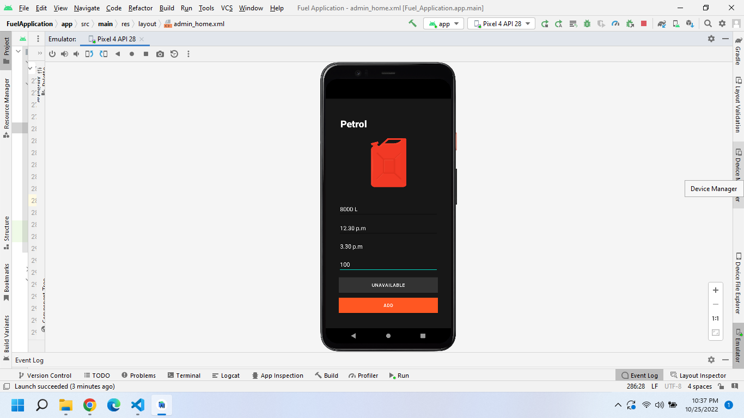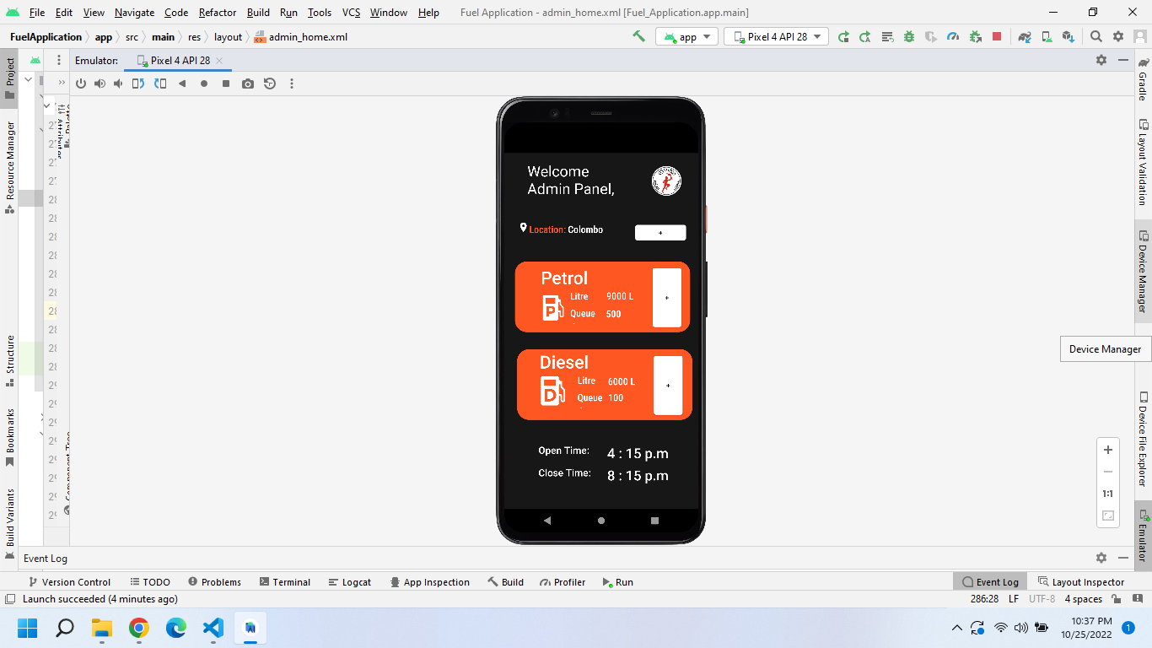

Figure : Petrol Status Manager

Figure : Welcome Admin Panel

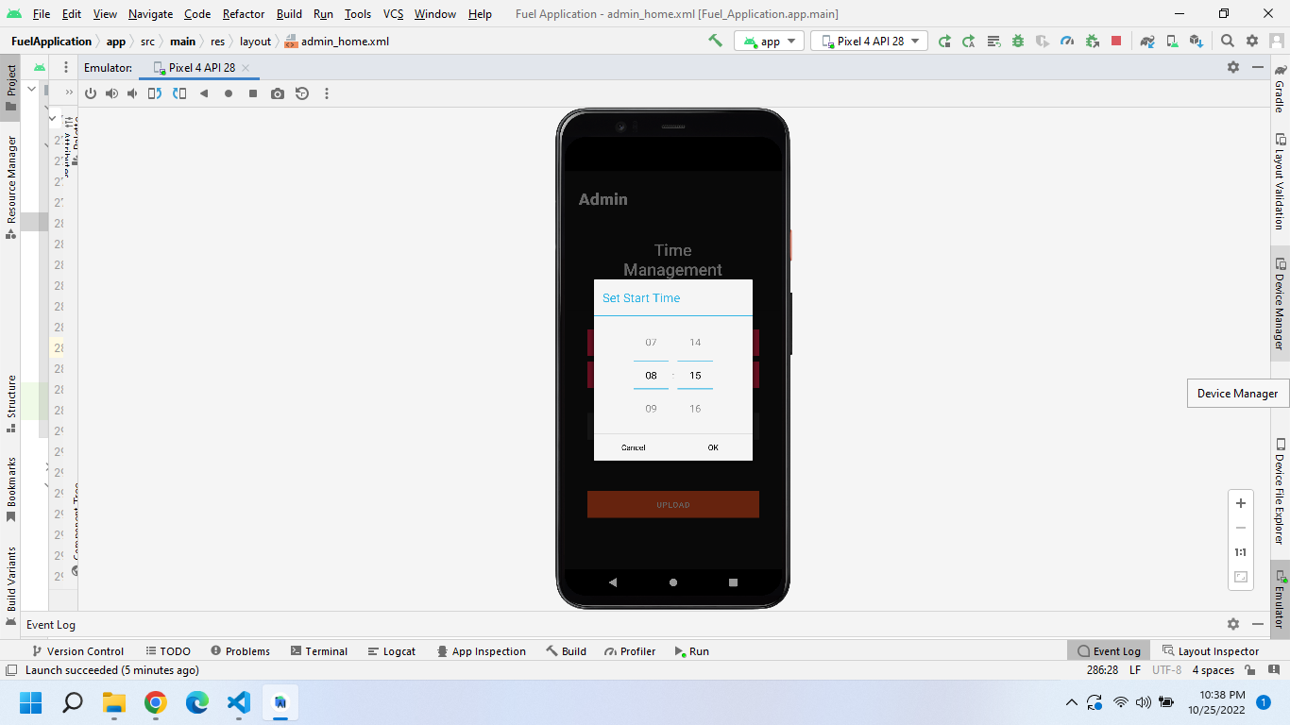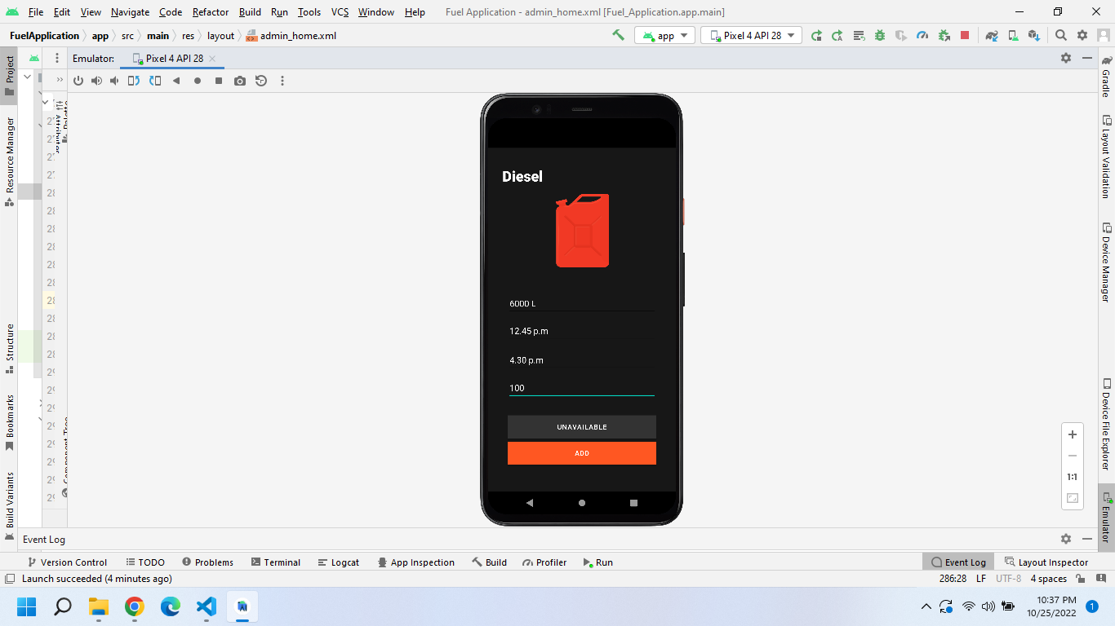

Figure : Set time Interface

Figure : Fuel Station Open and Closed Time Managment UI

Figure : Dielsel Status Managment UI

## 4.3 Code Base

*Admin_detals.xml*

<?xml version="1.0" encoding="utf-8"?>

<androidx.constraintlayout.widget.ConstraintLayout xmlns:android="http://schemas.android.com/apk/res/android"

    xmlns:app="http://schemas.android.com/apk/res-auto"

    xmlns:tools="http://schemas.android.com/tools"

    android:layout_width="match_parent"

    android:layout_height="match_parent"

    android:background="#171717"

    tools:context=".AdminDetailsAdd"

    >

    <!-- Admin-Shed-Time-Activity -->

    <EditText

        android:id="@+id/editTextTime"

        android:layout_width="match_parent"

        android:layout_height="wrap_content"

        android:ems="10"

        android:inputType="time"

        app:layout_constraintBottom_toBottomOf="parent"

        app:layout_constraintEnd_toEndOf="parent"

        app:layout_constraintHorizontal_bias="0.0"

        app:layout_constraintStart_toStartOf="parent"

        app:layout_constraintTop_toTopOf="parent"

        app:layout_constraintVertical_bias="0.317"

        tools:ignore="MissingConstraints" />

    <Button

        android:id="@+id/arrivalTimes"

        android:layout_width="311dp"

        android:layout_height="wrap_content"

        android:background="#3C3F41"

        android:onClick="onButtonSelectArrivalTimeClick"

        android:text="Set Start Time"

        app:backgroundTint="#FF2550"

        app:layout_constraintBottom_toBottomOf="parent"

        app:layout_constraintEnd_toEndOf="parent"

        app:layout_constraintStart_toStartOf="parent"

        app:layout_constraintTop_toTopOf="parent"

        app:layout_constraintVertical_bias="0.426" />

    <Button

        android:id="@+id/departureTimes"

        android:layout_width="311dp"

        android:layout_height="wrap_content"

        android:background="#3C3F41"

        android:onClick="onButtonSelectDepartureTimeClick"

        android:text="Set End Time"

        app:backgroundTint="#FF2550"

        app:layout_constraintBottom_toBottomOf="parent"

        app:layout_constraintEnd_toEndOf="parent"

        app:layout_constraintStart_toStartOf="parent"

        app:layout_constraintTop_toTopOf="parent"

        app:layout_constraintVertical_bias="0.513" />

    <Button

        android:id="@+id/departureTimesRev"

        android:layout_width="311dp"

        android:layout_height="wrap_content"

        android:background="#3C3F41"

        android:text="Remove Time"

        app:backgroundTint="#333333"

        app:layout_constraintBottom_toBottomOf="parent"

        app:layout_constraintEnd_toEndOf="parent"

        app:layout_constraintStart_toStartOf="parent"

        app:layout_constraintTop_toTopOf="parent"

        app:layout_constraintVertical_bias="0.651" />

    <Button

        android:id="@+id/addDetails"

        android:layout_width="311dp"

        android:layout_height="wrap_content"

        android:background="#3C3F41"

        android:text="UPLOAD"

        app:backgroundTint="#FF5722"

        app:layout_constraintBottom_toBottomOf="parent"

        app:layout_constraintEnd_toEndOf="parent"

        app:layout_constraintStart_toStartOf="parent"

        app:layout_constraintTop_toTopOf="parent"

        app:layout_constraintVertical_bias="0.862" />

    <TextView

        android:id="@+id/textView13"

        android:layout_width="230dp"

        android:layout_height="85dp"

        android:fontFamily="sans-serif-medium"

        android:gravity="center_horizontal"

        android:text="Time Management"

        android:textAlignment="center"

        android:textColor="@color/white"

        android:textSize="30sp"

        app:layout_constraintBottom_toBottomOf="parent"

        app:layout_constraintEnd_toEndOf="parent"

        app:layout_constraintHorizontal_bias="0.497"

        app:layout_constraintStart_toStartOf="parent"

        app:layout_constraintTop_toTopOf="parent"

        app:layout_constraintVertical_bias="0.191" />

    <TextView

        android:id="@+id/textView14"

        android:layout_width="125dp"

        android:layout_height="83dp"

        android:fontFamily="sans-serif-black"

        android:text="Admin"

        android:textColor="#FFFFFF"

        android:textSize="30sp"

        app:layout_constraintBottom_toBottomOf="parent"

        app:layout_constraintEnd_toEndOf="parent"

        app:layout_constraintHorizontal_bias="0.094"

        app:layout_constraintStart_toStartOf="parent"

        app:layout_constraintTop_toTopOf="parent"

        app:layout_constraintVertical_bias="0.046" />

</androidx.constraintlayout.widget.ConstraintLayout>

*Admin_disel.xml*

<?xml version="1.0" encoding="utf-8"?>

<androidx.constraintlayout.widget.ConstraintLayout xmlns:android="http://schemas.android.com/apk/res/android"

    xmlns:app="http://schemas.android.com/apk/res-auto"

    xmlns:tools="http://schemas.android.com/tools"

    android:layout_width="match_parent"

    android:layout_height="match_parent"

    android:background="#171717"

    tools:context=".RegisterUser">

    <!-- Admin-Diesel-Activity -->

    <EditText

        android:id="@+id/DeseldepartureTime"

        android:layout_width="311dp"

        android:layout_height="48dp"

        android:ems="10"

        android:hint="End Time"

        android:inputType="text|textEmailAddress"

        android:textColor="@color/white"

        android:textColorHint="#FF5722"

        app:layout_constraintBottom_toBottomOf="parent"

        app:layout_constraintEnd_toEndOf="parent"

        app:layout_constraintStart_toStartOf="parent"

        app:layout_constraintTop_toTopOf="parent"

        app:layout_constraintVertical_bias="0.626"

        tools:ignore="Missing Constrains" />

    <EditText

        android:id="@+id/DeselQueueSize"

        android:layout_width="311dp"

        android:layout_height="48dp"

        android:ems="10"

        android:hint="Queue Size"

        android:inputType="text|textEmailAddress"

        android:textColor="@color/white"

        android:textColorHint="#FF5722"

        app:layout_constraintBottom_toBottomOf="parent"

        app:layout_constraintEnd_toEndOf="parent"

        app:layout_constraintStart_toStartOf="parent"

        app:layout_constraintTop_toTopOf="parent"

        app:layout_constraintVertical_bias="0.713"

        tools:ignore="Missing Constrains" />

    <EditText

        android:id="@+id/Deselliters"

        android:layout_width="311dp"

        android:layout_height="48dp"

        android:ems="10"

        android:hint="Liters"

        android:inputType="text|textEmailAddress"

        android:textColor="@color/white"

        android:textColorHint="#FF5722"

        app:layout_constraintBottom_toBottomOf="parent"

        app:layout_constraintEnd_toEndOf="parent"

        app:layout_constraintStart_toStartOf="parent"

        app:layout_constraintTop_toTopOf="parent"

        app:layout_constraintVertical_bias="0.45"

        tools:ignore="Missing Constrains" />

    <EditText

        android:id="@+id/DeselarrivalTime"

        android:layout_width="311dp"

        android:layout_height="48dp"

        android:ems="10"

        android:hint="Start Time"

        android:inputType="text|textEmailAddress"

        android:textColor="@color/white"

        android:textColorHint="#FF5722"

        app:layout_constraintBottom_toBottomOf="parent"

        app:layout_constraintEnd_toEndOf="parent"

        app:layout_constraintStart_toStartOf="parent"

        app:layout_constraintTop_toTopOf="parent"

        app:layout_constraintVertical_bias="0.535"

        tools:ignore="Missing Constrains" />

    <Button

        android:id="@+id/deseladd"

        android:layout_width="311dp"

        android:layout_height="wrap_content"

        android:background="#3C3F41"

        android:text="Add"

        app:backgroundTint="#FF5722"

        app:layout_constraintBottom_toBottomOf="parent"

        app:layout_constraintEnd_toEndOf="parent"

        app:layout_constraintStart_toStartOf="parent"

        app:layout_constraintTop_toTopOf="parent"

        app:layout_constraintVertical_bias="0.916" />

    <Button

        android:id="@+id/deselunavil"

        android:layout_width="311dp"

        android:layout_height="wrap_content"

        android:background="#3C3F41"

        android:text="UNAVAILABLE"

        app:backgroundTint="#333333"

        app:layout_constraintBottom_toBottomOf="parent"

        app:layout_constraintEnd_toEndOf="parent"

        app:layout_constraintStart_toStartOf="parent"

        app:layout_constraintTop_toTopOf="parent"

        app:layout_constraintVertical_bias="0.834" />

    <ImageView

        android:id="@+id/imageView9"

        android:layout_width="228dp"

        android:layout_height="278dp"

        app:layout_constraintBottom_toBottomOf="parent"

        app:layout_constraintEnd_toEndOf="parent"

        app:layout_constraintHorizontal_bias="0.497"

        app:layout_constraintStart_toStartOf="parent"

        app:layout_constraintTop_toTopOf="parent"

        app:layout_constraintVertical_bias="0.066"

        app:srcCompat="@drawable/fuelcan" />

    <TextView

        android:id="@+id/textView6"

        android:layout_width="125dp"

        android:layout_height="83dp"

        android:fontFamily="sans-serif-black"

        android:text="Diesel"

        android:textColor="#FFFFFF"

        android:textSize="30sp"

        app:layout_constraintBottom_toBottomOf="parent"

        app:layout_constraintEnd_toEndOf="parent"

        app:layout_constraintHorizontal_bias="0.111"

        app:layout_constraintStart_toStartOf="parent"

        app:layout_constraintTop_toTopOf="parent"

        app:layout_constraintVertical_bias="0.06" />

    <Spinner

        android:id="@+id/spinner3"

        android:layout_width="match_parent"

        android:layout_height="wrap_content"

        android:layout_marginStart="32dp"

        android:layout_marginTop="32dp"

        android:layout_marginEnd="32dp"

        android:layout_marginBottom="32dp"

        android:background="#FFFFFF"

        android:spinnerMode="dropdown"

        app:layout_constraintBottom_toBottomOf="parent"

        app:layout_constraintEnd_toEndOf="parent"

        app:layout_constraintHorizontal_bias="0.0"

        app:layout_constraintStart_toStartOf="parent"

        app:layout_constraintTop_toTopOf="parent"

        app:layout_constraintVertical_bias="0.878" />

</androidx.constraintlayout.widget.ConstraintLayout>

*Admin_patrol.xml*

<?xml version="1.0" encoding="utf-8"?>

<androidx.constraintlayout.widget.ConstraintLayout xmlns:android="http://schemas.android.com/apk/res/android"

    xmlns:app="http://schemas.android.com/apk/res-auto"

    xmlns:tools="http://schemas.android.com/tools"

    android:layout_width="match_parent"

    android:layout_height="match_parent"

    android:background="#171717"

    tools:context=".AdminPatrolAdd">

    <!-- Admin-Patrol-Activity -->

    <Button

        android:id="@+id/patrolunavil"

        android:layout_width="311dp"

        android:layout_height="wrap_content"

        android:background="#3C3F41"

        android:text="UNAVAILABLE"

        app:backgroundTint="#333333"

        app:layout_constraintBottom_toBottomOf="parent"

        app:layout_constraintEnd_toEndOf="parent"

        app:layout_constraintStart_toStartOf="parent"

        app:layout_constraintTop_toTopOf="parent"

        app:layout_constraintVertical_bias="0.834" />

    <EditText

        android:id="@+id/PatrolqueueSize"

        android:layout_width="311dp"

        android:layout_height="48dp"

        android:ems="10"

        android:hint="Queue Size"

        android:inputType="text|textEmailAddress"

        android:textColor="@color/white"

        android:textColorHint="#FF5722"

        app:layout_constraintBottom_toBottomOf="parent"

        app:layout_constraintEnd_toEndOf="parent"

        app:layout_constraintStart_toStartOf="parent"

        app:layout_constraintTop_toTopOf="parent"

        app:layout_constraintVertical_bias="0.739"

        tools:ignore="Missing Constrains" />

    <EditText

        android:id="@+id/PatroldepartureTime"

        android:layout_width="311dp"

        android:layout_height="48dp"

        android:ems="10"

        android:hint="End Time"

        android:inputType="text|textEmailAddress"

        android:textColor="@color/white"

        android:textColorHint="#FF5722"

        app:layout_constraintBottom_toBottomOf="parent"

        app:layout_constraintEnd_toEndOf="parent"

        app:layout_constraintStart_toStartOf="parent"

        app:layout_constraintTop_toTopOf="parent"

        app:layout_constraintVertical_bias="0.654"

        tools:ignore="Missing Constrains" />

    <EditText

        android:id="@+id/PatrolarrivalTime"

        android:layout_width="311dp"

        android:layout_height="48dp"

        android:ems="10"

        android:hint="Start Time"

        android:inputType="text|textEmailAddress"

        android:textColor="@color/white"

        android:textColorHint="#FF5722"

        app:layout_constraintBottom_toBottomOf="parent"

        app:layout_constraintEnd_toEndOf="parent"

        app:layout_constraintStart_toStartOf="parent"

        app:layout_constraintTop_toTopOf="parent"

        app:layout_constraintVertical_bias="0.569"

        tools:ignore="Missing Constrains" />

    <EditText

        android:id="@+id/Patrolliters"

        android:layout_width="311dp"

        android:layout_height="48dp"

        android:ems="10"

        android:hint="Liters"

        android:inputType="text|textEmailAddress"

        android:textColor="@color/white"

        android:textColorHint="#FF5722"

        app:layout_constraintBottom_toBottomOf="parent"

        app:layout_constraintEnd_toEndOf="parent"

        app:layout_constraintStart_toStartOf="parent"

        app:layout_constraintTop_toTopOf="parent"

        app:layout_constraintVertical_bias="0.48"

        tools:ignore="Missing Constrains" />

    <Button

        android:id="@+id/PatrolAdd"

        android:layout_width="311dp"

        android:layout_height="wrap_content"

        android:background="#3C3F41"

        android:text="Add"

        app:backgroundTint="#FF5722"

        app:layout_constraintBottom_toBottomOf="parent"

        app:layout_constraintEnd_toEndOf="parent"

        app:layout_constraintStart_toStartOf="parent"

        app:layout_constraintTop_toTopOf="parent"

        app:layout_constraintVertical_bias="0.929" />

    <ImageView

        android:id="@+id/imageView9"

        android:layout_width="228dp"

        android:layout_height="238dp"

        app:layout_constraintBottom_toBottomOf="parent"

        app:layout_constraintEnd_toEndOf="parent"

        app:layout_constraintHorizontal_bias="0.497"

        app:layout_constraintStart_toStartOf="parent"

        app:layout_constraintTop_toTopOf="parent"

        app:layout_constraintVertical_bias="0.158"

        app:srcCompat="@drawable/fuelcan" />

    <TextView

        android:id="@+id/textView6"

        android:layout_width="125dp"

        android:layout_height="83dp"

        android:fontFamily="sans-serif-black"

        android:text="Petrol"

        android:textColor="#FFFFFF"

        android:textSize="30sp"

        app:layout_constraintBottom_toBottomOf="parent"

        app:layout_constraintEnd_toEndOf="parent"

        app:layout_constraintHorizontal_bias="0.174"

        app:layout_constraintStart_toStartOf="parent"

        app:layout_constraintTop_toTopOf="parent"

        app:layout_constraintVertical_bias="0.091" />

    <Spinner

        android:id="@+id/spinner3"

        android:layout_width="match_parent"

        android:layout_height="wrap_content"

        android:layout_marginStart="32dp"

        android:layout_marginTop="32dp"

        android:layout_marginEnd="32dp"

        android:layout_marginBottom="32dp"

        android:background="#FFFFFF"

        android:spinnerMode="dropdown"

        app:layout_constraintBottom_toBottomOf="parent"

        app:layout_constraintEnd_toEndOf="parent"

        app:layout_constraintHorizontal_bias="0.0"

        app:layout_constraintStart_toStartOf="parent"

        app:layout_constraintTop_toTopOf="parent"

        app:layout_constraintVertical_bias="0.893" />

</androidx.constraintlayout.widget.ConstraintLayout>

*Admin_home.xml*

<?xml version="1.0" encoding="utf-8"?>

<androidx.constraintlayout.widget.ConstraintLayout xmlns:android="http://schemas.android.com/apk/res/android"

    xmlns:app="http://schemas.android.com/apk/res-auto"

    xmlns:tools="http://schemas.android.com/tools"

    android:layout_width="match_parent"

    android:layout_height="match_parent"

    android:background="#171717"

    tools:context=".AdminHome">

    <!-- Admin-Home-Activity -->

    <ImageView

        android:id="@+id/imageView2"

        android:layout_width="427dp"

        android:layout_height="144dp"

        app:layout_constraintBottom_toBottomOf="parent"

        app:layout_constraintEnd_toEndOf="parent"

        app:layout_constraintHorizontal_bias="0.312"

        app:layout_constraintStart_toStartOf="parent"

        app:layout_constraintTop_toTopOf="parent"

        app:layout_constraintVertical_bias="0.689"

        app:srcCompat="@drawable/rect" />

    <Button

        android:id="@+id/dieseladd"

        android:layout_width="58dp"

        android:layout_height="131dp"

        android:text="+"

        android:textColor="@color/black"

        app:backgroundTint="#FFFFFF"

        app:layout_constraintBottom_toBottomOf="parent"

        app:layout_constraintEnd_toEndOf="parent"

        app:layout_constraintHorizontal_bias="0.905"

        app:layout_constraintStart_toStartOf="parent"

        app:layout_constraintTop_toTopOf="parent"

        app:layout_constraintVertical_bias="0.687" />

    <ImageView

        android:id="@+id/imageView6"

        android:layout_width="166dp"

        android:layout_height="215dp"

        app:layout_constraintBottom_toBottomOf="parent"

        app:layout_constraintEnd_toEndOf="parent"

        app:layout_constraintHorizontal_bias="0.069"

        app:layout_constraintStart_toStartOf="parent"

        app:layout_constraintTop_toTopOf="parent"

        app:layout_constraintVertical_bias="0.74"

        app:srcCompat="@drawable/dieseld" />

    <TextView

        android:id="@+id/textView5"

        android:layout_width="107dp"

        android:layout_height="48dp"

        android:fontFamily="sans-serif-medium"

        android:text="Diesel"

        android:textColor="#FFFFFF"

        android:textSize="36sp"

        app:layout_constraintBottom_toBottomOf="parent"

        app:layout_constraintEnd_toEndOf="@+id/imageView"

        app:layout_constraintHorizontal_bias="0.235"

        app:layout_constraintStart_toStartOf="parent"

        app:layout_constraintTop_toTopOf="parent"

        app:layout_constraintVertical_bias="0.592" />

    <TextView

        android:id="@+id/textView3"

        android:layout_width="196dp"

        android:layout_height="117dp"

        android:text="Welcome Admin Panel,"

        android:textColor="#FFFFFF"

        android:textSize="30sp"

        app:layout_constraintBottom_toBottomOf="parent"

        app:layout_constraintEnd_toEndOf="parent"

        app:layout_constraintHorizontal_bias="0.237"

        app:layout_constraintStart_toStartOf="parent"

        app:layout_constraintTop_toTopOf="parent"

        app:layout_constraintVertical_bias="0.026" />

    <ImageView

        android:id="@+id/imageView"

        android:layout_width="427dp"

        android:layout_height="144dp"

        app:layout_constraintBottom_toBottomOf="parent"

        app:layout_constraintEnd_toEndOf="parent"

        app:layout_constraintHorizontal_bias="0.437"

        app:layout_constraintStart_toStartOf="parent"

        app:layout_constraintTop_toTopOf="parent"

        app:layout_constraintVertical_bias="0.38"

        app:srcCompat="@drawable/rect" />

    <Button

        android:id="@+id/petroladd"

        android:layout_width="58dp"

        android:layout_height="131dp"

        android:text="+"

        android:textColor="@color/black"

        app:backgroundTint="#FFFFFF"

        app:layout_constraintBottom_toBottomOf="parent"

        app:layout_constraintEnd_toEndOf="parent"

        app:layout_constraintHorizontal_bias="0.898"

        app:layout_constraintStart_toStartOf="parent"

        app:layout_constraintTop_toTopOf="parent"

        app:layout_constraintVertical_bias="0.385" />

    <TextView

        android:id="@+id/ptliter"

        android:layout_width="44dp"

        android:layout_height="30dp"

        android:fontFamily="sans-serif-condensed-medium"

        android:text="Litre :"

        android:textAppearance="@style/TextAppearance.AppCompat.Body1"

        android:textColor="#FFFFFF"

        android:textSize="20sp"

        app:layout_constraintBottom_toBottomOf="parent"

        app:layout_constraintEnd_toEndOf="@+id/imageView"

        app:layout_constraintHorizontal_bias="0.363"

        app:layout_constraintStart_toStartOf="parent"

        app:layout_constraintTop_toTopOf="parent"

        app:layout_constraintVertical_bias="0.399" />

    <TextView

        android:id="@+id/ptliter2"

        android:layout_width="44dp"

        android:layout_height="30dp"

        android:fontFamily="sans-serif-condensed-medium"

        android:text="Litre :"

        android:textAppearance="@style/TextAppearance.AppCompat.Body1"

        android:textColor="#FFFFFF"

        android:textSize="20sp"

        app:layout_constraintBottom_toBottomOf="parent"

        app:layout_constraintEnd_toEndOf="@+id/imageView"

        app:layout_constraintHorizontal_bias="0.403"

        app:layout_constraintStart_toStartOf="parent"

        app:layout_constraintTop_toTopOf="parent"

        app:layout_constraintVertical_bias="0.646" />

    <TextView

        android:id="@+id/patrolLiters"

        android:layout_width="89dp"

        android:layout_height="27dp"

        android:fontFamily="sans-serif-condensed-medium"

        android:text=""

        android:textAppearance="@style/TextAppearance.AppCompat.Body1"

        android:textColor="#FFFFFF"

        android:textSize="20sp"

        app:layout_constraintBottom_toBottomOf="parent"

        app:layout_constraintEnd_toEndOf="@+id/imageView"

        app:layout_constraintHorizontal_bias="0.641"

        app:layout_constraintStart_toStartOf="parent"

        app:layout_constraintTop_toTopOf="parent"

        app:layout_constraintVertical_bias="0.397" />

    <TextView

        android:id="@+id/DeselLiters"

        android:layout_width="89dp"

        android:layout_height="27dp"

        android:fontFamily="sans-serif-condensed-medium"

        android:text=""

        android:textAppearance="@style/TextAppearance.AppCompat.Body1"

        android:textColor="#FFFFFF"

        android:textSize="20sp"

        app:layout_constraintBottom_toBottomOf="parent"

        app:layout_constraintEnd_toEndOf="@+id/imageView"

        app:layout_constraintHorizontal_bias="0.65"

        app:layout_constraintStart_toStartOf="parent"

        app:layout_constraintTop_toTopOf="parent"

        app:layout_constraintVertical_bias="0.647" />

    <TextView

        android:id="@+id/ptrQueue"

        android:layout_width="59dp"

        android:layout_height="36dp"

        android:fontFamily="sans-serif-condensed-medium"

        android:text="Queue  :"

        android:textAppearance="@style/TextAppearance.AppCompat.Body1"

        android:textColor="#FFFFFF"

        android:textSize="20sp"

        app:layout_constraintBottom_toBottomOf="parent"

        app:layout_constraintEnd_toEndOf="@+id/imageView"

        app:layout_constraintHorizontal_bias="0.378"

        app:layout_constraintStart_toStartOf="parent"

        app:layout_constraintTop_toTopOf="parent"

        app:layout_constraintVertical_bias="0.453" />

    <TextView

        android:id="@+id/ptrQueue2"

        android:layout_width="59dp"

        android:layout_height="36dp"

        android:fontFamily="sans-serif-condensed-medium"

        android:text="Queue  :"

        android:textAppearance="@style/TextAppearance.AppCompat.Body1"

        android:textColor="#FFFFFF"

        android:textSize="20sp"

        app:layout_constraintBottom_toBottomOf="parent"

        app:layout_constraintEnd_toEndOf="@+id/imageView"

        app:layout_constraintHorizontal_bias="0.419"

        app:layout_constraintStart_toStartOf="parent"

        app:layout_constraintTop_toTopOf="parent"

        app:layout_constraintVertical_bias="0.703" />

    <TextView

        android:id="@+id/patrolQueue"

        android:layout_width="90dp"

        android:layout_height="28dp"

        android:fontFamily="sans-serif-condensed-medium"

        android:text=""

        android:textAppearance="@style/TextAppearance.AppCompat.Body1"

        android:textColor="#FFFFFF"

        android:textSize="20sp"

        app:layout_constraintBottom_toBottomOf="parent"

        app:layout_constraintEnd_toEndOf="@+id/imageView"

        app:layout_constraintHorizontal_bias="0.64"

        app:layout_constraintStart_toStartOf="parent"

        app:layout_constraintTop_toTopOf="parent"

        app:layout_constraintVertical_bias="0.45" />

    <TextView

        android:id="@+id/DeselQueue"

        android:layout_width="59dp"

        android:layout_height="36dp"

        android:fontFamily="sans-serif-condensed-medium"

        android:text=""

        android:textAppearance="@style/TextAppearance.AppCompat.Body1"

        android:textColor="#FFFFFF"

        android:textSize="20sp"

        app:layout_constraintBottom_toBottomOf="parent"

        app:layout_constraintEnd_toEndOf="@+id/imageView"

        app:layout_constraintHorizontal_bias="0.596"

        app:layout_constraintStart_toStartOf="parent"

        app:layout_constraintTop_toTopOf="parent"

        app:layout_constraintVertical_bias="0.703" />

    <TextView

        android:id="@+id/textView4"

        android:layout_width="107dp"

        android:layout_height="48dp"

        android:fontFamily="sans-serif-medium"

        android:text="Petrol"

        android:textColor="#FFFFFF"

        android:textSize="36sp"

        app:layout_constraintBottom_toBottomOf="parent"

        app:layout_constraintEnd_toEndOf="@+id/imageView"

        app:layout_constraintHorizontal_bias="0.242"

        app:layout_constraintStart_toStartOf="parent"

        app:layout_constraintTop_toTopOf="parent"

        app:layout_constraintVertical_bias="0.338" />

    <ImageView

        android:id="@+id/imageView5"

        android:layout_width="144dp"

        android:layout_height="174dp"

        app:layout_constraintBottom_toBottomOf="parent"

        app:layout_constraintEnd_toEndOf="parent"

        app:layout_constraintHorizontal_bias="0.108"

        app:layout_constraintStart_toStartOf="parent"

        app:layout_constraintTop_toTopOf="parent"

        app:layout_constraintVertical_bias="0.414"

        app:srcCompat="@drawable/petrolp" />

    <TextView

        android:id="@+id/text_location"

        android:layout_width="98dp"

        android:layout_height="42dp"

        android:fontFamily="sans-serif-condensed-medium"

        android:text="Location: "

        android:textColor="#FF5722"

        android:textSize="20sp"

        app:layout_constraintBottom_toBottomOf="parent"

        app:layout_constraintEnd_toEndOf="parent"

        app:layout_constraintHorizontal_bias="0.172"

        app:layout_constraintStart_toStartOf="parent"

        app:layout_constraintTop_toTopOf="parent"

        app:layout_constraintVertical_bias="0.207" />

    <TextView

        android:id="@+id/stationname"

        android:layout_width="98dp"

        android:layout_height="42dp"

        android:fontFamily="sans-serif-condensed-medium"

        android:text=""

        android:textColor="#FFFFFF"

        android:textSize="20sp"

        app:layout_constraintBottom_toBottomOf="parent"

        app:layout_constraintEnd_toEndOf="parent"

        app:layout_constraintHorizontal_bias="0.437"

        app:layout_constraintStart_toStartOf="parent"

        app:layout_constraintTop_toTopOf="parent"

        app:layout_constraintVertical_bias="0.207" />

    <ImageView

        android:id="@+id/loc"

        android:layout_width="23dp"

        android:layout_height="39dp"

        app:layout_constraintBottom_toBottomOf="parent"

        app:layout_constraintEnd_toEndOf="parent"

        app:layout_constraintHorizontal_bias="0.074"

        app:layout_constraintStart_toStartOf="parent"

        app:layout_constraintTop_toTopOf="parent"

        app:layout_constraintVertical_bias="0.192"

        app:srcCompat="@drawable/loc" />

    <TextView

        android:id="@+id/textView"

        android:layout_width="133dp"

        android:layout_height="37dp"

        android:fontFamily="sans-serif-medium"

        android:text="Close Time: "

        android:textColor="#FFFFFF"

        android:textSize="20sp"

        app:layout_constraintBottom_toBottomOf="parent"

        app:layout_constraintEnd_toEndOf="parent"

        app:layout_constraintHorizontal_bias="0.266"

        app:layout_constraintStart_toStartOf="parent"

        app:layout_constraintTop_toTopOf="parent"

        app:layout_constraintVertical_bias="0.927"

        tools:ignore="MissingConstraints" />

    <TextView

        android:id="@+id/EndTimeField"

        android:layout_width="160dp"

        android:layout_height="37dp"

        android:fontFamily="sans-serif-medium"

        android:textColor="#FFFFFF"

        android:textSize="28sp"

        app:layout_constraintBottom_toBottomOf="parent"

        app:layout_constraintEnd_toEndOf="parent"

        app:layout_constraintHorizontal_bias="0.896"

        app:layout_constraintStart_toStartOf="parent"

        app:layout_constraintTop_toTopOf="parent"

        app:layout_constraintVertical_bias="0.927"

        tools:ignore="MissingConstraints" />

    <TextView

        android:id="@+id/StartTimeField"

        android:layout_width="160dp"

        android:layout_height="36dp"

        android:fontFamily="sans-serif-medium"

        android:textColor="#FFFFFF"

        android:textSize="28sp"

        app:layout_constraintBottom_toBottomOf="parent"

        app:layout_constraintEnd_toEndOf="parent"

        app:layout_constraintHorizontal_bias="0.896"

        app:layout_constraintStart_toStartOf="parent"

        app:layout_constraintTop_toTopOf="parent"

        app:layout_constraintVertical_bias="0.86"

        tools:ignore="MissingConstraints" />

    <TextView

        android:id="@+id/textView2"

        android:layout_width="136dp"

        android:layout_height="37dp"

        android:fontFamily="sans-serif-medium"

        android:text="Open Time:"

        android:textColor="#FFFFFF"

        android:textSize="20sp"

        app:layout_constraintBottom_toBottomOf="parent"

        app:layout_constraintEnd_toEndOf="parent"

        app:layout_constraintHorizontal_bias="0.269"

        app:layout_constraintStart_toStartOf="parent"

        app:layout_constraintTop_toTopOf="parent"

        app:layout_constraintVertical_bias="0.86"

        tools:ignore="MissingConstraints" />

    <Button

        android:id="@+id/detailss"

        android:layout_width="103dp"

        android:layout_height="43dp"

        android:text="+"

        android:textColor="@color/black"

        app:backgroundTint="#FFFFFF"

        app:layout_constraintBottom_toBottomOf="parent"

        app:layout_constraintEnd_toEndOf="parent"

        app:layout_constraintHorizontal_bias="0.915"

        app:layout_constraintStart_toStartOf="parent"

        app:layout_constraintTop_toTopOf="parent"

        app:layout_constraintVertical_bias="0.206"

        tools:ignore="MissingConstraints" />

    <ImageButton

        android:id="@+id/logout"

        android:layout_width="60dp"

        android:layout_height="60dp"

        android:background="#171717"

        android:scaleType="centerCrop"

        app:layout_constraintBottom_toBottomOf="parent"

        app:layout_constraintEnd_toEndOf="parent"

        app:layout_constraintHorizontal_bias="0.897"

        app:layout_constraintStart_toStartOf="parent"

        app:layout_constraintTop_toTopOf="parent"

        app:layout_constraintVertical_bias="0.04"

        app:srcCompat="@drawable/elecorg"

        tools:ignore="MissingConstraints" />

</androidx.constraintlayout.widget.ConstraintLayout>

# 5. IT19053592– User/Consumer Component

## 5.1 Introduction

This Component allows a registered fuel consumer/user to do following functionalities given below to ease their fuel needs without wasting time.

## 5.2 User Interfaces

Figure : Search for a particular Fuel Station

Figure : View Available Fuel Stations

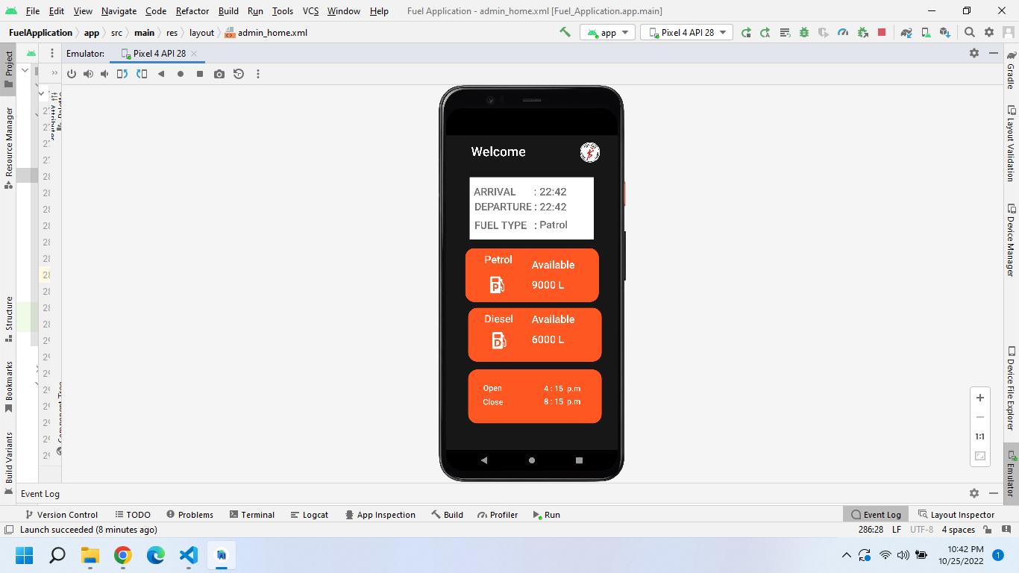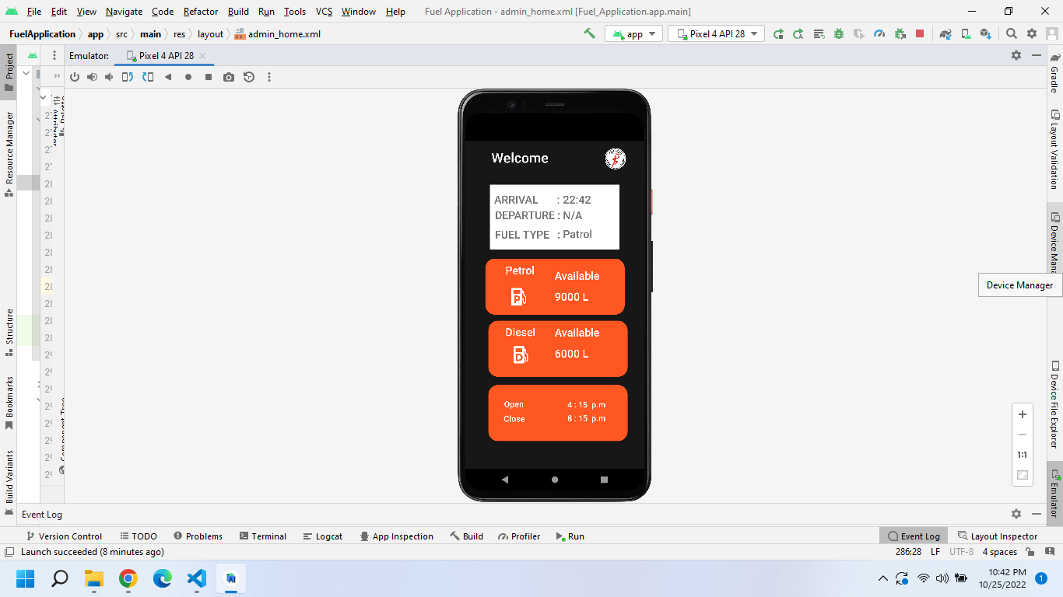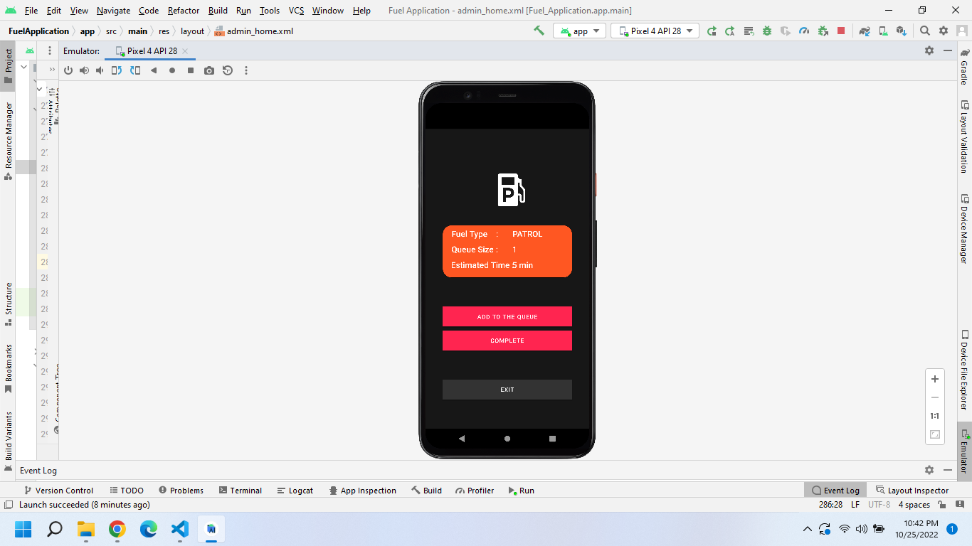

Figure : Fuel Station Status After Queue Entry

Figure : View the fuel statuses of a station

Figure : Enter to a Fuel Queue

## 5.3 Code Base

*activitiy_disel.xml*

<?xml version="1.0" encoding="utf-8"?>

<androidx.constraintlayout.widget.ConstraintLayout xmlns:android="http://schemas.android.com/apk/res/android"

    xmlns:app="http://schemas.android.com/apk/res-auto"

    xmlns:tools="http://schemas.android.com/tools"

    android:layout_width="match_parent"

    android:background="#171717"

    android:layout_height="match_parent"

    tools:context=".ShedDesel"

    >

    <!-- User-Shed-diesel-Activity -->

    <ImageView

        android:id="@+id/imageView8"

        android:layout_width="265dp"

        android:layout_height="294dp"

        android:background="#171717"

        app:layout_constraintBottom_toBottomOf="parent"

        app:layout_constraintEnd_toEndOf="parent"

        app:layout_constraintHorizontal_bias="0.582"

        app:layout_constraintStart_toStartOf="parent"

        app:layout_constraintTop_toTopOf="parent"

        app:layout_constraintVertical_bias="0.0"

        app:srcCompat="@drawable/dieseld" />

    <Button

        android:id="@+id/addToQueue"

        android:layout_width="311dp"

        android:layout_height="wrap_content"

        android:background="#3C3F41"

        android:onClick="onButtonSelectArrivalTimeClick"

        android:text="Add to the queue"

        app:backgroundTint="#FF2550"

        app:layout_constraintBottom_toBottomOf="parent"

        app:layout_constraintEnd_toEndOf="parent"

        app:layout_constraintStart_toStartOf="parent"

        app:layout_constraintTop_toTopOf="parent"

        app:layout_constraintVertical_bias="0.631" />

    <Button

        android:id="@+id/pExite"

        android:layout_width="311dp"

        android:layout_height="wrap_content"

        android:background="#3C3F41"

        android:onClick="onButtonSelectArrivalTimeClick"

        android:text="Exit"

        app:backgroundTint="#333333"

        app:layout_constraintBottom_toBottomOf="parent"

        app:layout_constraintEnd_toEndOf="parent"

        app:layout_constraintStart_toStartOf="parent"

        app:layout_constraintTop_toTopOf="parent"

        app:layout_constraintVertical_bias="0.916" />

    <Button

        android:id="@+id/pcomplete"

        android:layout_width="311dp"

        android:layout_height="wrap_content"

        android:background="#3C3F41"

        android:onClick="onButtonSelectArrivalTimeClick"

        android:text="Complete"

        app:backgroundTint="#FF2550"

        app:layout_constraintBottom_toBottomOf="parent"

        app:layout_constraintEnd_toEndOf="parent"

        app:layout_constraintStart_toStartOf="parent"

        app:layout_constraintTop_toTopOf="parent"

        app:layout_constraintVertical_bias="0.721" />

    <ImageView

        android:id="@+id/userPatrolbt2"

        android:layout_width="311dp"

        android:layout_height="144dp"

        app:layout_constraintBottom_toBottomOf="parent"

        app:layout_constraintEnd_toEndOf="parent"

        app:layout_constraintStart_toStartOf="parent"

        app:layout_constraintTop_toTopOf="parent"

        app:layout_constraintVertical_bias="0.386"

        app:srcCompat="@drawable/rect" />

    <TextView

        android:id="@+id/textView10"

        android:layout_width="137dp"

        android:layout_height="38dp"

        android:fontFamily="sans-serif-medium"

        android:text="Fuel Type    :"

        android:textColor="#FFFFFF"

        android:textSize="20sp"

        app:layout_constraintBottom_toBottomOf="parent"

        app:layout_constraintEnd_toEndOf="parent"

        app:layout_constraintHorizontal_bias="0.244"

        app:layout_constraintStart_toStartOf="parent"

        app:layout_constraintTop_toTopOf="parent"

        app:layout_constraintVertical_bias="0.359" />

    <TextView

        android:id="@+id/textView16"

        android:layout_width="137dp"

        android:layout_height="38dp"

        android:fontFamily="sans-serif-medium"

        android:text="DIESEL"

        android:textColor="#FFFFFF"

        android:textSize="20sp"

        app:layout_constraintBottom_toBottomOf="parent"

        app:layout_constraintEnd_toEndOf="parent"

        app:layout_constraintHorizontal_bias="0.777"

        app:layout_constraintStart_toStartOf="parent"

        app:layout_constraintTop_toTopOf="parent"

        app:layout_constraintVertical_bias="0.359" />

    <TextView

        android:id="@+id/dqueueSize"

        android:layout_width="137dp"

        android:layout_height="38dp"

        android:fontFamily="sans-serif-medium"

        android:inputType="phone"

        android:textColor="#FFFFFF"

        android:textSize="20sp"

        app:layout_constraintBottom_toBottomOf="parent"

        app:layout_constraintEnd_toEndOf="parent"

        app:layout_constraintHorizontal_bias="0.777"

        app:layout_constraintStart_toStartOf="parent"

        app:layout_constraintTop_toTopOf="parent"

        app:layout_constraintVertical_bias="0.435" />

    <TextView

        android:id="@+id/textView12"

        android:layout_width="148dp"

        android:layout_height="36dp"

        android:fontFamily="sans-serif-medium"

        android:text="Queue Size :"

        android:textColor="#FFFFFF"

        android:textSize="20sp"

        app:layout_constraintBottom_toBottomOf="parent"

        app:layout_constraintEnd_toEndOf="parent"

        app:layout_constraintHorizontal_bias="0.254"

        app:layout_constraintStart_toStartOf="parent"

        app:layout_constraintTop_toTopOf="parent"

        app:layout_constraintVertical_bias="0.435" />

</androidx.constraintlayout.widget.ConstraintLayout>

*activity_homel.xml*

<?xml version="1.0" encoding="utf-8"?>

<RelativeLayout xmlns:android="http://schemas.android.com/apk/res/android"

    xmlns:app="http://schemas.android.com/apk/res-auto"

    xmlns:tools="http://schemas.android.com/tools"

    android:layout_width="match_parent"

    android:layout_height="match_parent"

    android:background="#171717"

    tools:context=".Home">

    <!-- User-Home-page-Activity -->

    <ImageButton

        android:id="@+id/logoutHome"

        android:layout_width="60dp"

        android:layout_height="60dp"

        android:layout_alignParentStart="true"

        android:layout_alignParentTop="true"

        android:layout_alignParentEnd="true"

        android:layout_alignParentBottom="true"

        android:layout_marginStart="28dp"

        android:layout_marginTop="18dp"

        android:layout_marginEnd="322dp"

        android:layout_marginBottom="652dp"

        android:background="#171717"

        android:scaleType="centerCrop"

        app:layout_constraintBottom_toBottomOf="parent"

        app:layout_constraintEnd_toEndOf="parent"

        app:layout_constraintHorizontal_bias="0.897"

        app:layout_constraintStart_toStartOf="parent"

        app:layout_constraintTop_toTopOf="parent"

        app:layout_constraintVertical_bias="0.04"

        app:srcCompat="@drawable/elec"

        tools:ignore="MissingConstraints" />

    <TextView

        android:id="@+id/divider3"

        android:layout_width="370dp"

        android:layout_height="2dp"

        android:layout_alignParentStart="true"

        android:layout_alignParentEnd="true"

        android:layout_alignParentBottom="true"

        android:layout_marginStart="17dp"

        android:layout_marginEnd="23dp"

        android:layout_marginBottom="580dp"

        android:background="#FF5722"></TextView>

    <androidx.appcompat.widget.SearchView

        android:id="@+id/searchShed"

        android:layout_width="wrap_content"

        android:layout_height="51dp"

        android:layout_alignParentStart="true"

        android:layout_alignParentTop="true"

        android:layout_alignParentEnd="true"

        android:layout_alignParentBottom="true"

        android:layout_marginStart="17dp"

        android:layout_marginTop="93dp"

        android:layout_marginEnd="23dp"

        android:layout_marginBottom="587dp"

        android:background="#FFFF"

        app:queryHint="Search here..." />

    <androidx.recyclerview.widget.RecyclerView

        android:id="@+id/RecyclerView"

        android:layout_width="wrap_content"

        android:layout_height="538dp"

        android:layout_alignParentStart="true"

        android:layout_alignParentEnd="true"

        android:layout_alignParentBottom="true"

        android:layout_marginStart="17dp"

        android:layout_marginTop="110dp"

        android:layout_marginEnd="23dp"

        android:layout_marginBottom="19dp"

        android:textColor="#FFFFFF">

    </androidx.recyclerview.widget.RecyclerView>

</RelativeLayout>

*activity_patrol.xml*

<?xml version="1.0" encoding="utf-8"?>

<androidx.constraintlayout.widget.ConstraintLayout xmlns:android="http://schemas.android.com/apk/res/android"

    xmlns:app="http://schemas.android.com/apk/res-auto"

    xmlns:tools="http://schemas.android.com/tools"

    android:layout_width="match_parent"

    android:background="#171717"

    android:layout_height="match_parent"

    tools:context=".ShedPatrol"

    >

    <!-- User-Shed-Patrol-Activity -->

    <Button

        android:id="@+id/addtotheque"

        android:layout_width="311dp"

        android:layout_height="wrap_content"

        android:background="#3C3F41"

        android:onClick="onButtonSelectArrivalTimeClick"

        android:text="ADD TO THE QUEUE"

        app:backgroundTint="#FF2550"

        app:layout_constraintBottom_toBottomOf="parent"

        app:layout_constraintEnd_toEndOf="parent"

        app:layout_constraintStart_toStartOf="parent"

        app:layout_constraintTop_toTopOf="parent"

        app:layout_constraintVertical_bias="0.635" />

    <Button

        android:id="@+id/fuelcomplete"

        android:layout_width="311dp"

        android:layout_height="wrap_content"

        android:background="#3C3F41"

        android:onClick="onButtonSelectArrivalTimeClick"

        android:text="Complete"

        app:backgroundTint="#FF2550"

        app:layout_constraintBottom_toBottomOf="parent"

        app:layout_constraintEnd_toEndOf="parent"

        app:layout_constraintStart_toStartOf="parent"

        app:layout_constraintTop_toTopOf="parent"

        app:layout_constraintVertical_bias="0.721" />

    <Button

        android:id="@+id/fuelexites"

        android:layout_width="311dp"

        android:layout_height="wrap_content"

        android:background="#3C3F41"

        android:onClick="onButtonSelectArrivalTimeClick"

        android:text="Exit"

        app:backgroundTint="#333333"

        app:layout_constraintBottom_toBottomOf="parent"

        app:layout_constraintEnd_toEndOf="parent"

        app:layout_constraintStart_toStartOf="parent"

        app:layout_constraintTop_toTopOf="parent"

        app:layout_constraintVertical_bias="0.896" />

    <ImageView

        android:id="@+id/imageView7"

        android:layout_width="320dp"

        android:layout_height="221dp"

        app:layout_constraintBottom_toBottomOf="parent"

        app:layout_constraintEnd_toEndOf="parent"

        app:layout_constraintHorizontal_bias="0.637"

        app:layout_constraintStart_toStartOf="parent"

        app:layout_constraintTop_toTopOf="parent"

        app:layout_constraintVertical_bias="0.072"

        app:srcCompat="@drawable/petrolp" />

    <ImageView

        android:id="@+id/userPatrolbt2"

        android:layout_width="311dp"

        android:layout_height="144dp"

        app:layout_constraintBottom_toBottomOf="parent"

        app:layout_constraintEnd_toEndOf="parent"

        app:layout_constraintStart_toStartOf="parent"

        app:layout_constraintTop_toTopOf="parent"

        app:layout_constraintVertical_bias="0.386"

        app:srcCompat="@drawable/rect" />

    <TextView

        android:id="@+id/textView10"

        android:layout_width="137dp"

        android:layout_height="38dp"

        android:fontFamily="sans-serif-medium"

        android:text="Fuel Type    :"

        android:textColor="#FFFFFF"

        android:textSize="20sp"

        app:layout_constraintBottom_toBottomOf="parent"

        app:layout_constraintEnd_toEndOf="parent"

        app:layout_constraintHorizontal_bias="0.244"

        app:layout_constraintStart_toStartOf="parent"

        app:layout_constraintTop_toTopOf="parent"

        app:layout_constraintVertical_bias="0.349" />

    <TextView

        android:id="@+id/textView16"

        android:layout_width="137dp"

        android:layout_height="38dp"

        android:fontFamily="sans-serif-medium"

        android:text="PATROL"

        android:textColor="#FFFFFF"

        android:textSize="20sp"

        app:layout_constraintBottom_toBottomOf="parent"

        app:layout_constraintEnd_toEndOf="parent"

        app:layout_constraintHorizontal_bias="0.817"

        app:layout_constraintStart_toStartOf="parent"

        app:layout_constraintTop_toTopOf="parent"

        app:layout_constraintVertical_bias="0.349" />

    <TextView

        android:id="@+id/queueSize"

        android:layout_width="137dp"

        android:layout_height="38dp"

        android:fontFamily="sans-serif-medium"

        android:textColor="#FFFFFF"

        android:textSize="20sp"

        app:layout_constraintBottom_toBottomOf="parent"

        app:layout_constraintEnd_toEndOf="parent"

        app:layout_constraintHorizontal_bias="0.813"

        app:layout_constraintStart_toStartOf="parent"

        app:layout_constraintTop_toTopOf="parent"

        app:layout_constraintVertical_bias="0.404" />

    <TextView

        android:id="@+id/textView12"

        android:layout_width="148dp"

        android:layout_height="36dp"

        android:fontFamily="sans-serif-medium"

        android:text="Queue Size :"

        android:textColor="#FFFFFF"

        android:textSize="20sp"

        app:layout_constraintBottom_toBottomOf="parent"

        app:layout_constraintEnd_toEndOf="parent"

        app:layout_constraintHorizontal_bias="0.254"

        app:layout_constraintStart_toStartOf="parent"

        app:layout_constraintTop_toTopOf="parent"

        app:layout_constraintVertical_bias="0.402" />

    <TextView

        android:id="@+id/textView15"

        android:layout_width="189dp"

        android:layout_height="33dp"

        android:fontFamily="sans-serif-medium"

        android:text="Estimated Time :"

        android:textColor="#FFFFFF"

        android:textSize="20sp"

        app:layout_constraintBottom_toBottomOf="parent"

        app:layout_constraintEnd_toEndOf="parent"

        app:layout_constraintHorizontal_bias="0.301"

        app:layout_constraintStart_toStartOf="parent"

        app:layout_constraintTop_toTopOf="parent"

        app:layout_constraintVertical_bias="0.455" />

    <TextView

        android:id="@+id/PestimatedTime"

        android:layout_width="134dp"

        android:layout_height="33dp"

        android:fontFamily="sans-serif-medium"

        android:textColor="#FFFFFF"

        android:textSize="20sp"

        app:layout_constraintBottom_toBottomOf="parent"

        app:layout_constraintEnd_toEndOf="parent"

        app:layout_constraintHorizontal_bias="0.805"

        app:layout_constraintStart_toStartOf="parent"

        app:layout_constraintTop_toTopOf="parent"

        app:layout_constraintVertical_bias="0.455" />

</androidx.constraintlayout.widget.ConstraintLayout>

*Activity_shed.xml*

<?xml version="1.0" encoding="utf-8"?>

<androidx.constraintlayout.widget.ConstraintLayout xmlns:android="http://schemas.android.com/apk/res/android"

    xmlns:app="http://schemas.android.com/apk/res-auto"

    xmlns:tools="http://schemas.android.com/tools"

    android:layout_width="match_parent"

    android:layout_height="match_parent"

    android:background="#171717"

    tools:context=".Shed">

    <!-- User-Shed-Details-Activity -->

    <ImageButton

        android:id="@+id/logout3"

        android:layout_width="44dp"

        android:layout_height="46dp"

        android:background="#171717"

        android:scaleType="centerCrop"

        app:layout_constraintBottom_toBottomOf="parent"

        app:layout_constraintEnd_toEndOf="parent"

        app:layout_constraintHorizontal_bias="0.881"

        app:layout_constraintStart_toStartOf="parent"

        app:layout_constraintTop_toTopOf="parent"

        app:layout_constraintVertical_bias="0.023"

        app:srcCompat="@drawable/elecorg"

        tools:ignore="MissingConstraints" />

    <ImageView

        android:id="@+id/imageView4"

        android:layout_width="427dp"

        android:layout_height="124dp"

        app:layout_constraintBottom_toBottomOf="parent"

        app:layout_constraintEnd_toEndOf="parent"

        app:layout_constraintHorizontal_bias="0.312"

        app:layout_constraintStart_toStartOf="parent"

        app:layout_constraintTop_toTopOf="parent"

        app:layout_constraintVertical_bias="0.899"

        app:srcCompat="@drawable/rect" />

    <ImageView

        android:id="@+id/userDeselbt"

        android:layout_width="427dp"

        android:layout_height="124dp"

        android:contentDescription="TODO"

        app:layout_constraintBottom_toBottomOf="parent"

        app:layout_constraintEnd_toEndOf="parent"

        app:layout_constraintHorizontal_bias="0.312"

        app:layout_constraintStart_toStartOf="parent"

        app:layout_constraintTop_toTopOf="parent"

        app:layout_constraintVertical_bias="0.662"

        app:srcCompat="@drawable/rect" />

    <ImageView

        android:id="@+id/imageView6"

        android:layout_width="116dp"

        android:layout_height="107dp"

        app:layout_constraintBottom_toBottomOf="parent"

        app:layout_constraintEnd_toEndOf="parent"

        app:layout_constraintHorizontal_bias="0.23"

        app:layout_constraintStart_toStartOf="parent"

        app:layout_constraintTop_toTopOf="parent"

        app:layout_constraintVertical_bias="0.679"

        app:srcCompat="@drawable/dieseld" />

    <TextView

        android:id="@+id/textView5"

        android:layout_width="107dp"

        android:layout_height="48dp"

        android:layout_marginStart="88dp"

        android:fontFamily="sans-serif-medium"

        android:text="Diesel"

        android:textColor="#FFFFFF"

        android:textSize="24sp"

        app:layout_constraintBottom_toBottomOf="parent"

        app:layout_constraintEnd_toEndOf="@+id/imageView"

        app:layout_constraintHorizontal_bias="0.484"

        app:layout_constraintStart_toStartOf="parent"

        app:layout_constraintTop_toTopOf="parent"

        app:layout_constraintVertical_bias="0.6" />

    <TextView

        android:id="@+id/textView3"

        android:layout_width="205dp"

        android:layout_height="38dp"

        android:fontFamily="sans-serif-medium"

        android:text="Welcome "

        android:textColor="#FFFFFF"

        android:textSize="30sp"

        app:layout_constraintBottom_toBottomOf="parent"

        app:layout_constraintEnd_toEndOf="parent"

        app:layout_constraintHorizontal_bias="0.305"

        app:layout_constraintStart_toStartOf="parent"

        app:layout_constraintTop_toTopOf="parent"

        app:layout_constraintVertical_bias="0.023" />

    <ImageView

        android:id="@+id/userPatrolbt"

        android:layout_width="427dp"

        android:layout_height="124dp"

        app:layout_constraintBottom_toBottomOf="parent"

        app:layout_constraintEnd_toEndOf="parent"

        app:layout_constraintStart_toStartOf="parent"

        app:layout_constraintTop_toTopOf="parent"

        app:layout_constraintVertical_bias="0.433"

        app:srcCompat="@drawable/rect" />

    <TextView

        android:id="@+id/textView4"

        android:layout_width="107dp"

        android:layout_height="48dp"

        android:layout_marginStart="88dp"

        android:fontFamily="sans-serif-medium"

        android:text="Petrol"

        android:textColor="#FFFFFF"

        android:textSize="24sp"

        app:layout_constraintBottom_toBottomOf="parent"

        app:layout_constraintEnd_toEndOf="@+id/imageView"

        app:layout_constraintHorizontal_bias="0.484"

        app:layout_constraintStart_toStartOf="parent"

        app:layout_constraintTop_toTopOf="parent"

        app:layout_constraintVertical_bias="0.398" />

    <TextView

        android:id="@+id/ptavalable"

        android:layout_width="139dp"

        android:layout_height="47dp"

        android:layout_marginStart="196dp"

        android:fontFamily="sans-serif-medium"

        android:text=""

        android:textColor="#FFFFFF"

        android:textSize="24sp"

        app:layout_constraintBottom_toBottomOf="parent"

        app:layout_constraintEnd_toEndOf="@+id/imageView"

        app:layout_constraintHorizontal_bias="0.484"

        app:layout_constraintStart_toStartOf="parent"

        app:layout_constraintTop_toTopOf="parent"

        app:layout_constraintVertical_bias="0.415" />

    <TextView

        android:id="@+id/ptliters"

        android:layout_width="139dp"

        android:layout_height="47dp"

        android:layout_marginStart="196dp"

        android:fontFamily="sans-serif-medium"

        android:text=""

        android:textColor="#FFFFFF"

        android:textSize="24sp"

        app:layout_constraintBottom_toBottomOf="parent"

        app:layout_constraintEnd_toEndOf="@+id/imageView"

        app:layout_constraintHorizontal_bias="0.484"

        app:layout_constraintStart_toStartOf="parent"

        app:layout_constraintTop_toTopOf="parent"

        app:layout_constraintVertical_bias="0.483" />

    <TextView

        android:id="@+id/dsliters"

        android:layout_width="139dp"

        android:layout_height="47dp"

        android:layout_marginStart="196dp"

        android:fontFamily="sans-serif-medium"

        android:text=""

        android:textColor="#FFFFFF"

        android:textSize="24sp"

        app:layout_constraintBottom_toBottomOf="parent"

        app:layout_constraintStart_toStartOf="parent"

        app:layout_constraintTop_toTopOf="parent"

        app:layout_constraintVertical_bias="0.669" />

    <TextView

        android:id="@+id/dsavailable"

        android:layout_width="139dp"

        android:layout_height="47dp"

        android:layout_marginStart="196dp"

        android:fontFamily="sans-serif-medium"

        android:text=""

        android:textColor="#FFFFFF"

        android:textSize="24sp"

        app:layout_constraintBottom_toBottomOf="parent"

        app:layout_constraintStart_toStartOf="parent"

        app:layout_constraintTop_toTopOf="parent"

        app:layout_constraintVertical_bias="0.6" />

    <ImageView

        android:id="@+id/imageView5"

        android:layout_width="110dp"

        android:layout_height="109dp"

        app:layout_constraintBottom_toBottomOf="parent"

        app:layout_constraintEnd_toEndOf="parent"

        app:layout_constraintHorizontal_bias="0.219"

        app:layout_constraintStart_toStartOf="parent"

        app:layout_constraintTop_toTopOf="parent"

        app:layout_constraintVertical_bias="0.471"

        app:srcCompat="@drawable/petrolp" />

    <TextView

        android:id="@+id/textView"

        android:layout_width="100dp"

        android:layout_height="30dp"

        android:layout_marginBottom="92dp"

        android:fontFamily="sans-serif-medium"

        android:text="Close"

        android:textColor="#FFFFFF"

        android:textSize="18sp"

        app:layout_constraintBottom_toBottomOf="parent"

        app:layout_constraintEnd_toEndOf="@+id/imageView4"

        app:layout_constraintHorizontal_bias="0.29"

        app:layout_constraintStart_toStartOf="@+id/imageView4"

        app:layout_constraintTop_toBottomOf="@+id/imageView2"

        app:layout_constraintVertical_bias="0.293"

        tools:ignore="MissingConstraints" />

    <TextView

        android:id="@+id/timeClose"

        android:layout_width="100dp"

        android:layout_height="30dp"

        android:fontFamily="sans-serif-medium"

        android:textColor="#FFFFFF"

        android:textSize="18sp"

        app:layout_constraintBottom_toBottomOf="@+id/imageView4"

        app:layout_constraintEnd_toEndOf="@+id/imageView4"

        app:layout_constraintHorizontal_bias="0.718"

        app:layout_constraintStart_toStartOf="@+id/imageView4"

        app:layout_constraintTop_toTopOf="@+id/imageView4"

        app:layout_constraintVertical_bias="0.648"

        tools:ignore="MissingConstraints" />

    <TextView

        android:id="@+id/timeOPen"

        android:layout_width="100dp"

        android:layout_height="30dp"

        android:fontFamily="sans-serif-medium"

        android:textColor="#FFFFFF"

        android:textSize="18sp"

        app:layout_constraintBottom_toBottomOf="@+id/imageView4"

        app:layout_constraintEnd_toEndOf="@+id/imageView4"

        app:layout_constraintHorizontal_bias="0.718"

        app:layout_constraintStart_toStartOf="@+id/imageView4"

        app:layout_constraintTop_toTopOf="@+id/imageView4"

        app:layout_constraintVertical_bias="0.329"

        tools:ignore="MissingConstraints" />

    <TextView

        android:id="@+id/textView2"

        android:layout_width="100dp"

        android:layout_height="30dp"

        android:layout_marginBottom="64dp"

        android:fontFamily="sans-serif-medium"

        android:text="Open"

        android:textColor="#FFFFFF"

        android:textSize="18sp"

        app:layout_constraintBottom_toBottomOf="@+id/imageView4"

        app:layout_constraintEnd_toEndOf="@+id/imageView4"

        app:layout_constraintHorizontal_bias="0.293"

        app:layout_constraintStart_toStartOf="@+id/imageView4"

        app:layout_constraintTop_toBottomOf="@+id/imageView2"

        app:layout_constraintVertical_bias="0.295"

        tools:ignore="MissingConstraints" />

    <TextView

        android:id="@+id/textView8"

        android:layout_width="284dp"

        android:layout_height="142dp"

        android:background="#FFFF"

        app:backgroundTint="#FFFF"

        app:layout_constraintBottom_toBottomOf="parent"

        app:layout_constraintEnd_toEndOf="parent"

        app:layout_constraintHorizontal_bias="0.496"

        app:layout_constraintStart_toStartOf="parent"

        app:layout_constraintTop_toTopOf="parent"

        app:layout_constraintVertical_bias="0.166"

        tools:ignore="MissingConstraints" />

    <TextView

        android:id="@+id/arrivTimetoQue"

        android:layout_width="138dp"

        android:layout_height="35dp"

        android:fontFamily="sans-serif-medium"

        android:textSize="24sp"

        app:layout_constraintBottom_toBottomOf="parent"

        app:layout_constraintEnd_toEndOf="parent"

        app:layout_constraintHorizontal_bias="0.842"

        app:layout_constraintStart_toStartOf="parent"

        app:layout_constraintTop_toTopOf="parent"

        app:layout_constraintVertical_bias="0.163" />

    <TextView

        android:id="@+id/departureTimetoQue"

        android:layout_width="138dp"

        android:layout_height="35dp"

        android:fontFamily="sans-serif-medium"

        android:textSize="24sp"

        app:layout_constraintBottom_toBottomOf="parent"

        app:layout_constraintEnd_toEndOf="parent"

        app:layout_constraintHorizontal_bias="0.842"

        app:layout_constraintStart_toStartOf="parent"

        app:layout_constraintTop_toTopOf="parent"

        app:layout_constraintVertical_bias="0.214" />

    <TextView

        android:id="@+id/fuelTypeShed"

        android:layout_width="138dp"

        android:layout_height="35dp"

        android:fontFamily="sans-serif-medium"

        android:textSize="24sp"

        app:layout_constraintBottom_toBottomOf="parent"

        app:layout_constraintEnd_toEndOf="parent"

        app:layout_constraintHorizontal_bias="0.842"

        app:layout_constraintStart_toStartOf="parent"

        app:layout_constraintTop_toTopOf="parent"

        app:layout_constraintVertical_bias="0.274" />

    <TextView

        android:id="@+id/textView9"

        android:layout_width="148dp"

        android:layout_height="35dp"

        android:fontFamily="sans-serif-medium"

        android:text="ARRIVAL       : "

        android:textSize="24sp"

        app:layout_constraintBottom_toBottomOf="parent"

        app:layout_constraintEnd_toEndOf="parent"

        app:layout_constraintHorizontal_bias="0.258"

        app:layout_constraintStart_toStartOf="parent"

        app:layout_constraintTop_toTopOf="parent"

        app:layout_constraintVertical_bias="0.163" />

    <TextView

        android:id="@+id/textView7"

        android:layout_width="145dp"

        android:layout_height="34dp"

        android:fontFamily="sans-serif-medium"

        android:text="DEPARTURE :"

        android:textSize="24sp"

        app:layout_constraintBottom_toBottomOf="parent"

        app:layout_constraintEnd_toEndOf="parent"

        app:layout_constraintHorizontal_bias="0.263"

        app:layout_constraintStart_toStartOf="parent"

        app:layout_constraintTop_toTopOf="parent"

        app:layout_constraintVertical_bias="0.213" />

    <TextView

        android:id="@+id/textView11"

        android:layout_width="145dp"

        android:layout_height="34dp"

        android:fontFamily="sans-serif-medium"

        android:text="FUEL TYPE   :"

        android:textSize="24sp"

        app:layout_constraintBottom_toBottomOf="parent"

        app:layout_constraintEnd_toEndOf="parent"

        app:layout_constraintHorizontal_bias="0.263"

        app:layout_constraintStart_toStartOf="parent"

        app:layout_constraintTop_toTopOf="parent"

        app:layout_constraintVertical_bias="0.275" />

</androidx.constraintlayout.widget.ConstraintLayout>

*shed_list.xml*

<?xml version="1.0" encoding="utf-8"?>

<androidx.constraintlayout.widget.ConstraintLayout xmlns:android="http://schemas.android.com/apk/res/android"

    xmlns:app="http://schemas.android.com/apk/res-auto"

    xmlns:tools="http://schemas.android.com/tools"

    android:layout_width="match_parent"

    android:layout_height="match_parent"

    android:background="#171717"

    tools:context=".Shed">

    <!-- User-Shed-Details-Activity -->

    <ImageButton

        android:id="@+id/logout3"

        android:layout_width="44dp"

        android:layout_height="46dp"

        android:background="#171717"

        android:scaleType="centerCrop"

        app:layout_constraintBottom_toBottomOf="parent"

        app:layout_constraintEnd_toEndOf="parent"

        app:layout_constraintHorizontal_bias="0.881"

        app:layout_constraintStart_toStartOf="parent"

        app:layout_constraintTop_toTopOf="parent"

        app:layout_constraintVertical_bias="0.023"

        app:srcCompat="@drawable/elecorg"

        tools:ignore="MissingConstraints" />

    <ImageView

        android:id="@+id/imageView4"

        android:layout_width="427dp"

        android:layout_height="124dp"

        app:layout_constraintBottom_toBottomOf="parent"

        app:layout_constraintEnd_toEndOf="parent"

        app:layout_constraintHorizontal_bias="0.312"

        app:layout_constraintStart_toStartOf="parent"

        app:layout_constraintTop_toTopOf="parent"

        app:layout_constraintVertical_bias="0.899"

        app:srcCompat="@drawable/rect" />

    <ImageView

        android:id="@+id/userDeselbt"

        android:layout_width="427dp"

        android:layout_height="124dp"

        android:contentDescription="TODO"

        app:layout_constraintBottom_toBottomOf="parent"

        app:layout_constraintEnd_toEndOf="parent"

        app:layout_constraintHorizontal_bias="0.312"

        app:layout_constraintStart_toStartOf="parent"

        app:layout_constraintTop_toTopOf="parent"

        app:layout_constraintVertical_bias="0.662"

        app:srcCompat="@drawable/rect" />

    <ImageView

        android:id="@+id/imageView6"

        android:layout_width="116dp"

        android:layout_height="107dp"

        app:layout_constraintBottom_toBottomOf="parent"

        app:layout_constraintEnd_toEndOf="parent"

        app:layout_constraintHorizontal_bias="0.23"

        app:layout_constraintStart_toStartOf="parent"

        app:layout_constraintTop_toTopOf="parent"

        app:layout_constraintVertical_bias="0.679"

        app:srcCompat="@drawable/dieseld" />

    <TextView

        android:id="@+id/textView5"

        android:layout_width="107dp"

        android:layout_height="48dp"

        android:layout_marginStart="88dp"

        android:fontFamily="sans-serif-medium"

        android:text="Diesel"

        android:textColor="#FFFFFF"

        android:textSize="24sp"

        app:layout_constraintBottom_toBottomOf="parent"

        app:layout_constraintEnd_toEndOf="@+id/imageView"

        app:layout_constraintHorizontal_bias="0.484"

        app:layout_constraintStart_toStartOf="parent"

        app:layout_constraintTop_toTopOf="parent"

        app:layout_constraintVertical_bias="0.6" />

    <TextView

        android:id="@+id/textView3"

        android:layout_width="205dp"

        android:layout_height="38dp"

        android:fontFamily="sans-serif-medium"

        android:text="Welcome "

        android:textColor="#FFFFFF"

        android:textSize="30sp"

        app:layout_constraintBottom_toBottomOf="parent"

        app:layout_constraintEnd_toEndOf="parent"

        app:layout_constraintHorizontal_bias="0.305"

        app:layout_constraintStart_toStartOf="parent"

        app:layout_constraintTop_toTopOf="parent"

        app:layout_constraintVertical_bias="0.023" />

    <ImageView

        android:id="@+id/userPatrolbt"

        android:layout_width="427dp"

        android:layout_height="124dp"

        app:layout_constraintBottom_toBottomOf="parent"

        app:layout_constraintEnd_toEndOf="parent"

        app:layout_constraintStart_toStartOf="parent"

        app:layout_constraintTop_toTopOf="parent"

        app:layout_constraintVertical_bias="0.433"

        app:srcCompat="@drawable/rect" />

    <TextView

        android:id="@+id/textView4"

        android:layout_width="107dp"

        android:layout_height="48dp"

        android:layout_marginStart="88dp"

        android:fontFamily="sans-serif-medium"

        android:text="Petrol"

        android:textColor="#FFFFFF"

        android:textSize="24sp"

        app:layout_constraintBottom_toBottomOf="parent"

        app:layout_constraintEnd_toEndOf="@+id/imageView"

        app:layout_constraintHorizontal_bias="0.484"

        app:layout_constraintStart_toStartOf="parent"

        app:layout_constraintTop_toTopOf="parent"

        app:layout_constraintVertical_bias="0.398" />

    <TextView

        android:id="@+id/ptavalable"

        android:layout_width="139dp"

        android:layout_height="47dp"

        android:layout_marginStart="196dp"

        android:fontFamily="sans-serif-medium"

        android:text=""

        android:textColor="#FFFFFF"

        android:textSize="24sp"

        app:layout_constraintBottom_toBottomOf="parent"

        app:layout_constraintEnd_toEndOf="@+id/imageView"

        app:layout_constraintHorizontal_bias="0.484"

        app:layout_constraintStart_toStartOf="parent"

        app:layout_constraintTop_toTopOf="parent"

        app:layout_constraintVertical_bias="0.415" />

    <TextView

        android:id="@+id/ptliters"

        android:layout_width="139dp"

        android:layout_height="47dp"

        android:layout_marginStart="196dp"

        android:fontFamily="sans-serif-medium"

        android:text=""

        android:textColor="#FFFFFF"

        android:textSize="24sp"

        app:layout_constraintBottom_toBottomOf="parent"

        app:layout_constraintEnd_toEndOf="@+id/imageView"

        app:layout_constraintHorizontal_bias="0.484"

        app:layout_constraintStart_toStartOf="parent"

        app:layout_constraintTop_toTopOf="parent"

        app:layout_constraintVertical_bias="0.483" />

    <TextView

        android:id="@+id/dsliters"

        android:layout_width="139dp"

        android:layout_height="47dp"

        android:layout_marginStart="196dp"

        android:fontFamily="sans-serif-medium"

        android:text=""

        android:textColor="#FFFFFF"

        android:textSize="24sp"

        app:layout_constraintBottom_toBottomOf="parent"

        app:layout_constraintStart_toStartOf="parent"

        app:layout_constraintTop_toTopOf="parent"

        app:layout_constraintVertical_bias="0.669" />

    <TextView

        android:id="@+id/dsavailable"

        android:layout_width="139dp"

        android:layout_height="47dp"

        android:layout_marginStart="196dp"

        android:fontFamily="sans-serif-medium"

        android:text=""

        android:textColor="#FFFFFF"

        android:textSize="24sp"

        app:layout_constraintBottom_toBottomOf="parent"

        app:layout_constraintStart_toStartOf="parent"

        app:layout_constraintTop_toTopOf="parent"

        app:layout_constraintVertical_bias="0.6" />

    <ImageView

        android:id="@+id/imageView5"

        android:layout_width="110dp"

        android:layout_height="109dp"

        app:layout_constraintBottom_toBottomOf="parent"

        app:layout_constraintEnd_toEndOf="parent"

        app:layout_constraintHorizontal_bias="0.219"

        app:layout_constraintStart_toStartOf="parent"

        app:layout_constraintTop_toTopOf="parent"

        app:layout_constraintVertical_bias="0.471"

        app:srcCompat="@drawable/petrolp" />

    <TextView

        android:id="@+id/textView"

        android:layout_width="100dp"

        android:layout_height="30dp"

        android:layout_marginBottom="92dp"

        android:fontFamily="sans-serif-medium"

        android:text="Close"

        android:textColor="#FFFFFF"

        android:textSize="18sp"

        app:layout_constraintBottom_toBottomOf="parent"

        app:layout_constraintEnd_toEndOf="@+id/imageView4"

        app:layout_constraintHorizontal_bias="0.29"

        app:layout_constraintStart_toStartOf="@+id/imageView4"

        app:layout_constraintTop_toBottomOf="@+id/imageView2"

        app:layout_constraintVertical_bias="0.293"

        tools:ignore="MissingConstraints" />

    <TextView

        android:id="@+id/timeClose"

        android:layout_width="100dp"

        android:layout_height="30dp"

        android:fontFamily="sans-serif-medium"

        android:textColor="#FFFFFF"

        android:textSize="18sp"

        app:layout_constraintBottom_toBottomOf="@+id/imageView4"

        app:layout_constraintEnd_toEndOf="@+id/imageView4"

        app:layout_constraintHorizontal_bias="0.718"

        app:layout_constraintStart_toStartOf="@+id/imageView4"

        app:layout_constraintTop_toTopOf="@+id/imageView4"

        app:layout_constraintVertical_bias="0.648"

        tools:ignore="MissingConstraints" />

    <TextView

        android:id="@+id/timeOPen"

        android:layout_width="100dp"

        android:layout_height="30dp"

        android:fontFamily="sans-serif-medium"

        android:textColor="#FFFFFF"

        android:textSize="18sp"

        app:layout_constraintBottom_toBottomOf="@+id/imageView4"

        app:layout_constraintEnd_toEndOf="@+id/imageView4"

        app:layout_constraintHorizontal_bias="0.718"

        app:layout_constraintStart_toStartOf="@+id/imageView4"

        app:layout_constraintTop_toTopOf="@+id/imageView4"

        app:layout_constraintVertical_bias="0.329"

        tools:ignore="MissingConstraints" />

    <TextView

        android:id="@+id/textView2"

        android:layout_width="100dp"

        android:layout_height="30dp"

        android:layout_marginBottom="64dp"

        android:fontFamily="sans-serif-medium"

        android:text="Open"

        android:textColor="#FFFFFF"

        android:textSize="18sp"

        app:layout_constraintBottom_toBottomOf="@+id/imageView4"

        app:layout_constraintEnd_toEndOf="@+id/imageView4"

        app:layout_constraintHorizontal_bias="0.293"

        app:layout_constraintStart_toStartOf="@+id/imageView4"

        app:layout_constraintTop_toBottomOf="@+id/imageView2"

        app:layout_constraintVertical_bias="0.295"

        tools:ignore="MissingConstraints" />

    <TextView

        android:id="@+id/textView8"

        android:layout_width="284dp"

        android:layout_height="142dp"

        android:background="#FFFF"

        app:backgroundTint="#FFFF"

        app:layout_constraintBottom_toBottomOf="parent"

        app:layout_constraintEnd_toEndOf="parent"

        app:layout_constraintHorizontal_bias="0.496"

        app:layout_constraintStart_toStartOf="parent"

        app:layout_constraintTop_toTopOf="parent"

        app:layout_constraintVertical_bias="0.166"

        tools:ignore="MissingConstraints" />

    <TextView

        android:id="@+id/arrivTimetoQue"

        android:layout_width="138dp"

        android:layout_height="35dp"

        android:fontFamily="sans-serif-medium"

        android:textSize="24sp"

        app:layout_constraintBottom_toBottomOf="parent"

        app:layout_constraintEnd_toEndOf="parent"

        app:layout_constraintHorizontal_bias="0.842"

        app:layout_constraintStart_toStartOf="parent"

        app:layout_constraintTop_toTopOf="parent"

        app:layout_constraintVertical_bias="0.163" />

    <TextView

        android:id="@+id/departureTimetoQue"

        android:layout_width="138dp"

        android:layout_height="35dp"

        android:fontFamily="sans-serif-medium"

        android:textSize="24sp"

        app:layout_constraintBottom_toBottomOf="parent"

        app:layout_constraintEnd_toEndOf="parent"

        app:layout_constraintHorizontal_bias="0.842"

        app:layout_constraintStart_toStartOf="parent"

        app:layout_constraintTop_toTopOf="parent"

        app:layout_constraintVertical_bias="0.214" />

    <TextView

        android:id="@+id/fuelTypeShed"

        android:layout_width="138dp"

        android:layout_height="35dp"

        android:fontFamily="sans-serif-medium"

        android:textSize="24sp"

        app:layout_constraintBottom_toBottomOf="parent"

        app:layout_constraintEnd_toEndOf="parent"

        app:layout_constraintHorizontal_bias="0.842"

        app:layout_constraintStart_toStartOf="parent"

        app:layout_constraintTop_toTopOf="parent"

        app:layout_constraintVertical_bias="0.274" />

    <TextView

        android:id="@+id/textView9"

        android:layout_width="148dp"

        android:layout_height="35dp"

        android:fontFamily="sans-serif-medium"

        android:text="ARRIVAL       : "

        android:textSize="24sp"

        app:layout_constraintBottom_toBottomOf="parent"

        app:layout_constraintEnd_toEndOf="parent"

        app:layout_constraintHorizontal_bias="0.258"

        app:layout_constraintStart_toStartOf="parent"

        app:layout_constraintTop_toTopOf="parent"

        app:layout_constraintVertical_bias="0.163" />

    <TextView

        android:id="@+id/textView7"

        android:layout_width="145dp"

        android:layout_height="34dp"

        android:fontFamily="sans-serif-medium"

        android:text="DEPARTURE :"

        android:textSize="24sp"

        app:layout_constraintBottom_toBottomOf="parent"

        app:layout_constraintEnd_toEndOf="parent"

        app:layout_constraintHorizontal_bias="0.263"

        app:layout_constraintStart_toStartOf="parent"

        app:layout_constraintTop_toTopOf="parent"

        app:layout_constraintVertical_bias="0.213" />

    <TextView

        android:id="@+id/textView11"

        android:layout_width="145dp"

        android:layout_height="34dp"

        android:fontFamily="sans-serif-medium"

        android:text="FUEL TYPE   :"

        android:textSize="24sp"

        app:layout_constraintBottom_toBottomOf="parent"

        app:layout_constraintEnd_toEndOf="parent"

        app:layout_constraintHorizontal_bias="0.263"

        app:layout_constraintStart_toStartOf="parent"

        app:layout_constraintTop_toTopOf="parent"

        app:layout_constraintVertical_bias="0.275" />

</androidx.constraintlayout.widget.ConstraintLayout>

# 6. IT19063492–Login/Registration Component

## 6.1 Introduction

This Component allows all end users (Fuel Consumer/ Fuel Station Owner) to register the System and Login.

## 6.2 User Interfaces

Figure : User Registration

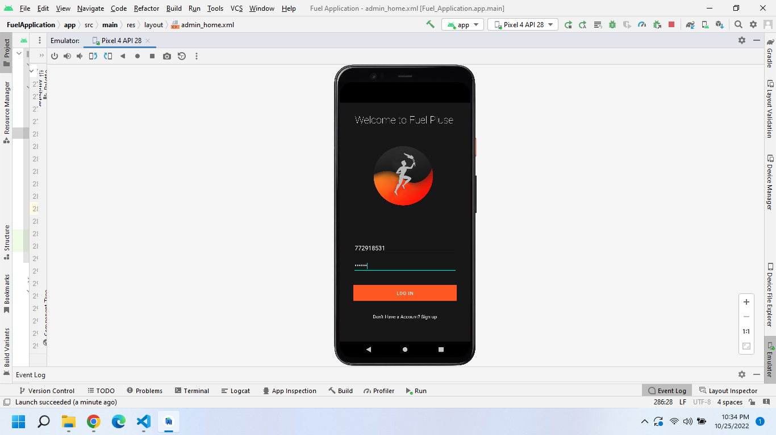

Figure : Login UI

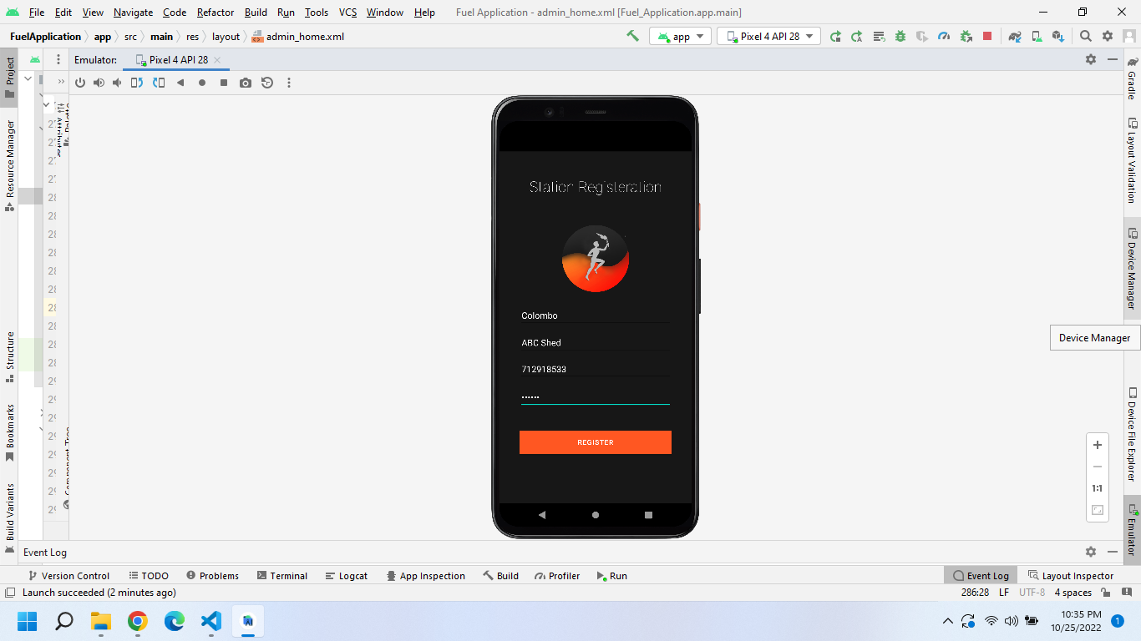

Figure : Fuel Station Owner Registation

## 6.3 Code Base

*Activity_main.xml*

<?xml version="1.0" encoding="utf-8"?>

<androidx.constraintlayout.widget.ConstraintLayout xmlns:android="http://schemas.android.com/apk/res/android"

  xmlns:app="http://schemas.android.com/apk/res-auto"

    xmlns:tools="http://schemas.android.com/tools"

    android:layout_width="match_parent"

    android:layout_height="match_parent"

    android:background="#171717"

    android:padding="30dp"

    tools:context=".MainActivity"

    >

    <!-- Login-Activity -->

    <Button

        android:id="@+id/login"

        android:layout_width="311dp"

        android:layout_height="wrap_content"

        android:background="#3C3F41"

        android:text="Log in"

        app:backgroundTint="#FF5722"

        app:layout_constraintBottom_toBottomOf="parent"

        app:layout_constraintEnd_toEndOf="parent"

        app:layout_constraintStart_toStartOf="parent"

        app:layout_constraintTop_toTopOf="parent"

        app:layout_constraintVertical_bias="0.85" />

    <EditText

        android:id="@+id/auemail"

        android:layout_width="311dp"

        android:layout_height="40dp"

        android:ems="10"

        android:hint="Phone"

        android:inputType="text|textEmailAddress"

        android:textColor="@color/white"

        android:textColorHint="#FF5722"

        app:layout_constraintBottom_toBottomOf="parent"

        app:layout_constraintEnd_toEndOf="parent"

        app:layout_constraintStart_toStartOf="parent"

        app:layout_constraintTop_toTopOf="parent"

        app:layout_constraintVertical_bias="0.63"

        tools:ignore="Missing Constrains" />

    <EditText

        android:id="@+id/aupassword"

        android:layout_width="311dp"

        android:layout_height="40dp"

        android:ems="10"

        android:hint="Password"

        android:inputType="text|textPassword"

        android:textColor="@color/white"

        android:textColorHint="#FF5722"

        app:layout_constraintBottom_toBottomOf="parent"

        app:layout_constraintEnd_toEndOf="parent"

        app:layout_constraintStart_toStartOf="parent"

        app:layout_constraintTop_toTopOf="parent"

        app:layout_constraintVertical_bias="0.715"

        tools:ignore="Missing Constrains" />

    <ImageView

        android:id="@+id/imageView3"

        android:layout_width="262dp"

        android:layout_height="377dp"

        app:layout_constraintBottom_toBottomOf="parent"

        app:layout_constraintEnd_toEndOf="parent"

        app:layout_constraintHorizontal_bias="0.423"

        app:layout_constraintStart_toStartOf="parent"

        app:layout_constraintTop_toTopOf="parent"

        app:layout_constraintVertical_bias="0.004"

        app:srcCompat="@drawable/logo" />

    <TextView

        android:id="@+id/banner"

        android:layout_width="wrap_content"

        android:layout_height="wrap_content"

        android:layout_gravity="center_horizontal"

        android:fontFamily="sans-serif-thin"

        android:gravity="center_horizontal"

        android:text="Welcome to Fuel Pluse"

        android:textAlignment="center"

        android:textColor="@color/white"

        android:textSize="30sp"

        app:layout_constraintBottom_toBottomOf="parent"

        app:layout_constraintEnd_toEndOf="parent"

        app:layout_constraintHorizontal_bias="0.431"

        app:layout_constraintStart_toStartOf="parent"

        app:layout_constraintTop_toTopOf="parent"

        app:layout_constraintVertical_bias="0.0" />

    <TextView

        android:id="@+id/register"

        android:layout_width="wrap_content"

        android:layout_height="wrap_content"

        android:text="Don't Have a Account? Sign up"

        android:textColor="#FFFFFF"

        app:layout_constraintBottom_toBottomOf="parent"

        app:layout_constraintEnd_toEndOf="parent"

        app:layout_constraintHorizontal_bias="0.498"

        app:layout_constraintStart_toStartOf="parent"

        app:layout_constraintTop_toTopOf="parent"

        app:layout_constraintVertical_bias="0.945" />

</androidx.constraintlayout.widget.ConstraintLayout>

*Activity_register.xml*

<?xml version="1.0" encoding="utf-8"?>

<androidx.constraintlayout.widget.ConstraintLayout xmlns:android="http://schemas.android.com/apk/res/android"

    xmlns:app="http://schemas.android.com/apk/res-auto"

    xmlns:tools="http://schemas.android.com/tools"

    android:layout_width="match_parent"

    android:layout_height="match_parent"

    android:background="#171717"

    tools:context=".RegisterUser">

      <!-- User-registration-Activity -->

        <TextView

            android:id="@+id/adminRegisterTab"

            android:layout_width="wrap_content"

            android:layout_height="wrap_content"

            android:text="Fuel Station? Sign up"

            android:textColor="#FFFFFF"

            app:layout_constraintBottom_toBottomOf="parent"

            app:layout_constraintEnd_toEndOf="parent"

            app:layout_constraintHorizontal_bias="0.498"

            app:layout_constraintStart_toStartOf="parent"

            app:layout_constraintTop_toTopOf="parent"

            app:layout_constraintVertical_bias="0.921" />

        <EditText

            android:id="@+id/password"

            android:layout_width="311dp"

            android:layout_height="40dp"

            android:ems="10"

            android:hint="Password"

            android:inputType="text|textPassword"

            android:textColor="@color/white"

            android:textColorHint="#FF5722"

            app:layout_constraintBottom_toBottomOf="parent"

            app:layout_constraintEnd_toEndOf="parent"

            app:layout_constraintStart_toStartOf="parent"

            app:layout_constraintTop_toTopOf="parent"

            app:layout_constraintVertical_bias="0.715"

            tools:ignore="Missing Constrains" />

        <EditText

            android:id="@+id/email"

            android:layout_width="311dp"

            android:layout_height="40dp"

            android:ems="10"

            android:hint="Phone"

            android:inputType="text|textEmailAddress"

            android:textColor="@color/white"

            android:textColorHint="#FF5722"

            app:layout_constraintBottom_toBottomOf="parent"

            app:layout_constraintEnd_toEndOf="parent"

            app:layout_constraintStart_toStartOf="parent"

            app:layout_constraintTop_toTopOf="parent"

            app:layout_constraintVertical_bias="0.63"

            tools:ignore="Missing Constrains" />

        <EditText

            android:id="@+id/fullname"

            android:layout_width="311dp"

            android:layout_height="40dp"

            android:ems="10"

            android:hint="Full Name"

            android:inputType="textPersonName"

            android:textColor="@color/white"

            android:textColorHint="#FF5722"

            app:layout_constraintBottom_toBottomOf="parent"

            app:layout_constraintEnd_toEndOf="parent"

            app:layout_constraintStart_toStartOf="parent"

            app:layout_constraintTop_toTopOf="parent"

            app:layout_constraintVertical_bias="0.468" />

        <EditText

            android:id="@+id/vehicle"

            android:layout_width="311dp"

            android:layout_height="48dp"

            android:ems="10"

            android:hint="Vehicle"

            android:inputType="text"

            android:textColor="@color/white"

            android:textColorHint="#FF5722"

            app:layout_constraintBottom_toBottomOf="parent"

            app:layout_constraintEnd_toEndOf="parent"

            app:layout_constraintStart_toStartOf="parent"

            app:layout_constraintTop_toTopOf="parent"

            app:layout_constraintVertical_bias="0.547"

            tools:ignore="Missing Constrains" />

        <ImageView

            android:id="@+id/imageView3"

            android:layout_width="201dp"

            android:layout_height="352dp"

            app:layout_constraintBottom_toBottomOf="parent"

            app:layout_constraintEnd_toEndOf="parent"

            app:layout_constraintStart_toStartOf="parent"

            app:layout_constraintTop_toTopOf="parent"

            app:layout_constraintVertical_bias="0.117"

            app:srcCompat="@drawable/logo" />

        <TextView

            android:id="@+id/banner"

            android:layout_width="wrap_content"

            android:layout_height="wrap_content"

            android:layout_gravity="center_horizontal"

            android:fontFamily="sans-serif-thin"

            android:gravity="center_horizontal"

            android:text="Registeration"

            android:textAlignment="center"

            android:textColor="@color/white"

            android:textSize="30sp"

            app:layout_constraintBottom_toBottomOf="parent"

            app:layout_constraintEnd_toEndOf="parent"

            app:layout_constraintStart_toStartOf="parent"

            app:layout_constraintTop_toTopOf="parent"

            app:layout_constraintVertical_bias="0.075" />

        <Button

            android:id="@+id/registerUser"

            android:layout_width="311dp"

            android:layout_height="wrap_content"

            android:background="#3C3F41"

            android:text="Register"

            app:backgroundTint="#FF5722"

            app:layout_constraintBottom_toBottomOf="parent"

            app:layout_constraintEnd_toEndOf="parent"

            app:layout_constraintStart_toStartOf="parent"

            app:layout_constraintTop_toTopOf="parent"

            app:layout_constraintVertical_bias="0.85"

           />

</androidx.constraintlayout.widget.ConstraintLayout>

*admin_register.xml*

<?xml version="1.0" encoding="utf-8"?>

<androidx.constraintlayout.widget.ConstraintLayout xmlns:android="http://schemas.android.com/apk/res/android"

    xmlns:app="http://schemas.android.com/apk/res-auto"

    xmlns:tools="http://schemas.android.com/tools"

    android:layout_width="match_parent"

    android:layout_height="match_parent"

    android:background="#171717"

    tools:context=".AdminRegister">

    <!-- Admin-registration-Activity -->

    <EditText

        android:id="@+id/Adpassword"

        android:layout_width="311dp"

        android:layout_height="40dp"

        android:ems="10"

        android:hint="Password"

        android:inputType="text|textPassword"

        android:textColor="@color/white"

        android:textColorHint="#FF5722"

        app:layout_constraintBottom_toBottomOf="parent"

        app:layout_constraintEnd_toEndOf="parent"

        app:layout_constraintStart_toStartOf="parent"

        app:layout_constraintTop_toTopOf="parent"

        app:layout_constraintVertical_bias="0.715"

        tools:ignore="Missing Constrains" />

    <EditText

        android:id="@+id/Adphone"

        android:layout_width="311dp"

        android:layout_height="40dp"

        android:ems="10"

        android:hint="Phone"

        android:inputType="text|textEmailAddress"

        android:textColor="@color/white"

        android:textColorHint="#FF5722"

        app:layout_constraintBottom_toBottomOf="parent"

        app:layout_constraintEnd_toEndOf="parent"

        app:layout_constraintStart_toStartOf="parent"

        app:layout_constraintTop_toTopOf="parent"

        app:layout_constraintVertical_bias="0.63"

        tools:ignore="Missing Constrains" />

    <EditText

        android:id="@+id/AdFullName"

        android:layout_width="311dp"

        android:layout_height="40dp"

        android:ems="10"

        android:hint="Location"

        android:inputType="textPersonName"

        android:textColor="@color/white"

        android:textColorHint="#FF5722"

        app:layout_constraintBottom_toBottomOf="parent"

        app:layout_constraintEnd_toEndOf="parent"

        app:layout_constraintStart_toStartOf="parent"

        app:layout_constraintTop_toTopOf="parent"

        app:layout_constraintVertical_bias="0.468" />

    <EditText

        android:id="@+id/AdStationName"

        android:layout_width="311dp"

        android:layout_height="48dp"

        android:ems="10"

        android:hint="Station Name"

        android:inputType="text"

        android:textColor="@color/white"

        android:textColorHint="#FF5722"

        app:layout_constraintBottom_toBottomOf="parent"

        app:layout_constraintEnd_toEndOf="parent"

        app:layout_constraintStart_toStartOf="parent"

        app:layout_constraintTop_toTopOf="parent"

        app:layout_constraintVertical_bias="0.547"

        tools:ignore="Missing Constrains" />

    <ImageView

        android:id="@+id/imageView3"

        android:layout_width="201dp"

        android:layout_height="352dp"

        app:layout_constraintBottom_toBottomOf="parent"

        app:layout_constraintEnd_toEndOf="parent"

        app:layout_constraintStart_toStartOf="parent"

        app:layout_constraintTop_toTopOf="parent"

        app:layout_constraintVertical_bias="0.117"

        app:srcCompat="@drawable/logo" />

    <TextView

        android:id="@+id/banner"

        android:layout_width="wrap_content"

        android:layout_height="wrap_content"

        android:layout_gravity="center_horizontal"

        android:fontFamily="sans-serif-thin"

        android:gravity="center_horizontal"

        android:text="Station Registeration"

        android:textAlignment="center"

        android:textColor="@color/white"

        android:textSize="30sp"

        app:layout_constraintBottom_toBottomOf="parent"

        app:layout_constraintEnd_toEndOf="parent"

        app:layout_constraintStart_toStartOf="parent"

        app:layout_constraintTop_toTopOf="parent"

        app:layout_constraintVertical_bias="0.075" />

    <Button

        android:id="@+id/AdregisterUser"

        android:layout_width="311dp"

        android:layout_height="wrap_content"

        android:background="#3C3F41"

        android:text="Register"

        app:backgroundTint="#FF5722"

        app:layout_constraintBottom_toBottomOf="parent"

        app:layout_constraintEnd_toEndOf="parent"

        app:layout_constraintStart_toStartOf="parent"

        app:layout_constraintTop_toTopOf="parent"

        app:layout_constraintVertical_bias="0.85"

        />

</androidx.constraintlayout.widget.ConstraintLayout>